

**Data Driven Decision Making**

*Data Driven Analysis of Traffic Accidents:*

*what causes them, how can we prevent them, and can we predict them?*

*Virajdatt Kohir*

*Rudraksh Mishra*

*Lakshmi Kavuri*

*Arnav Gupta*

*Manish Ranjan*

*Sameer Mahajan*

**School of Graduate Professional Studies**

MPS in Data Analytics

DAAN 881 – Data Driven Decision Making

(Spring 2, 2022)

# Document Control

## Work carried out by:

|  |  |  |
| --- | --- | --- |
| **Name** | **Email Address** | **Task description** |
| Virajdatt Kohir | vvk5220@psu.edu | Project idea suggestion, abstract documentation, pitch formation, Dataset description |
| Rudraksh Mishra | rjm7016@psu.edu | abstract documentation, pitch formation, updating document based on suggested corrections |
| Arnav Gupta | arg5956@psu.edu | abstract documentation, pitch formation |
| Lakshmi Kavuri | lkk5341@psu.edu | abstract documentation, pitch formation |
| Manish Ranjan | mzr5838@psu.edu | abstract documentation, pitch formation |
| Sameer Mahajan | sam7736@psu.edu | Dataset description |

## Revision Sheet:

|  |  |  |
| --- | --- | --- |
| **Release No.** | **Date** | **Revision Description** |
| 1.0 | 03-17-2022 | Initial Abstract and Pitch Draft (pages 1-3 and 11-27) |
| 2.0 | 03-22-2022 | Dataset description and updates to previous submission (page 4-6 and page 1-3) |
| 3.0 | 03-30-2022 | Updated with descriptive analysis of dataset. |
| 4.0 | 04-07-2022 | Updated with Data Cleaning and Progress report. |
| 5.0 | 04-13-2022 | Updated the figures to be properly labeled and data transformation section. |
| 6.0 | 04-19-2022 | Modelling part is completed and answered the descriptive question (page 33-40) |
| 7.0 | 04-26-2022 | Updated as peer feedbacks like model interpretation, LR timings and perspective solution (page 37-38) |
| 8.0 | 04-28-2022 | Addressed peer feedbacks received (page 33-50), the points that were addressed are on page 50. |

# TABLE OF CONTENTS

**Abstract………………………………………………………………………………………….01**

**Project Proposal: ……………………………………………………………………………….02**

**Dataset Description: ...………………………………………………………………………….04**

**Descriptive analysis……………………………………………………………………………..06**

**Data Cleaning: ……………….…………………………………………………………………20**

**Data Transformation: ………………………………………………………………………….26**

**Approach………………………………………………………………………………………..33**

**Appendix: ……………………………………………………………………………………….40**

**References: ……………………………………………………………………………………...69**

# Abstract

People lose lives, a lot of damage is caused to vehicles and the roads, which dents not only a person's earnings, but also government’s resources, either the backlash caused after the accidents or the criticism to the government and in sum accidents are bad. In this project, we perform a comprehensive analysis of the past accidents and perform a systematic study and data analysis to gain insights into what caused these incidents and with the application of Data Driven Decision Making Algorithms and methods, we try to establish a framework which can be used to take preventive measures to avoid these catastrophic incidents to a great extent.

In this analysis we want to study (descriptive analysis):

1. Which of the two conditions (lighting or weather) had a serious impact on the accidents?

2. What are the regions or areas with the most frequent accidents?

Predictive question:

1. Can we predict these incidents in advance to aid the general public and the other interested parties?

Prescriptive question:

1. What steps should be taken by the ministry of transportation and traffic authorities to prevent or minimize the road accident?

Equipped with these insights, the Ministry of Transportation and Traffic Authorities can work in synergy and help the general cause to aid the commonwealth.

The dataset [1] has a great many variables and comes from the real world as opposed to many other academic datasets. The study will focus on a handful of variables required to answer the questions listed above but care is taken to analyze the rest of the variables to provide future directions. This data will assist us with our descriptive and predictive analysis. It consists of the necessary variables like light conditions, weather conditions to answer our business queries and develop our prescriptive analysis.

# Project Proposal

Our target audience will be Ministry of Transportation and Traffic Authorities. Additionally, the general public who drive or are driven in a vehicle.

The various stakeholders need to understand which areas are the most affected by accidents. A comprehensive understanding of the conditions is required to understand why accidents happen and what can be done to avoid these things. Ministry of Transportation needs to be able to predict the accidents in order to gear up manpower to deploy to the accident zone and allocate more resources to areas with higher accident rates.

Causal drivers or beginners need to know what routes not to take to avoid accident prone zones. At the same time, allocate a few more resources to the alternate routes for road quality and awareness boards, so that these low accident-prone areas do not have an increase in number of accidents.

The current study doesn’t cover the analysis if the driver was under any drug/alcohol influence, but there indeed is a need for authorities to make better policies and fines.

We will address the stakeholder’s need by achieving goals through exploring and providing descriptive, predictive and perspective analysis.

The descriptive part of the analysis will focus on the lighting conditions of road, the weather conditions and provide a summary of what factors have been observed in past accidents. This analysis also focuses on understanding the areas which are most prone to accident zones, so as to mark the red zones.

The predictive part of the analysis focuses on trying to build a forecasting model which can use the various variables in the dataset to predict the number of casualties for different routes. Through this, we will be able to predict the number of accidents that can happen in a particular road or route in the near future.

The prescriptive part of the analysis is focusing on steps needs to implement by gaining deeper insights into the underlying causes of road accidents, which can be implemented by the Ministry of Transportation and Traffic Authorities to prevent or minimize accidents them before they occur.

The accumulated findings of both the descriptive and predictive modelling ultimately serves as the input for the prescriptive phase of the project. These inputs, along with the secondary research and domain knowledge will aid in better decision making. The perspective part finally will be driven by the above 2 analysis and will focus majorly on coming up with decisions driven by data for better road management, resource allocation and awareness boards, which will be beneficial for the Ministry of Transportation.

This research project facilitates the implementation of the 7 pre-set objectives of the Data driven decision making course through:

● Creating a better understanding of the legal and ethical aspects of Data, cleaning, and analysis.

● Strengthening the concepts and skills for statistical analysis through data cleaning, aggregation, and descriptive statistical analysis.

● Create and optimize predictive modelling/algorithms based on real-life data, with the objective of ultimately creating effective business decisions.

● Utilization of various statistical performance indicators, dimensionality reduction techniques (when appropriate) using various programming languages to effectively analyze the data.

● Provide opportunity for the soft skills development by fostering teamwork & collaborative approach to problem solving.

● Illustrating through example, the sequence of steps needed from problem identification to effective decision making within the real world.

Analyzing such dataset will help us with applying the statistical concepts reviewed and learnt in the course. This project will help us improve our analytics as well as communication skills to aid the decision-makers. It will assist us in upskilling our Python and R knowledge to apply to the algorithms and solve real-world decision-making problems. We can also learn how to utilize the statistical performance indicators across these domains for better decision-making.

For the team to deliver a professional grade product, it must conduct itself in the same manner. Thus, complying with the legal and ethical aspects of data collection and usage, following deadlines, being responsive to the employer and professionally laying out the scope and limitations of the research are of paramount importance.

# Dataset Description

The dataset we have chosen has the following files:

1. Train.csv
2. Population.csv
3. Road_networks.csv

We will be primarily using train.csv. The rest of the 2 files may be explored additionally during the model evaluation and updating phase. The 3 files have the **postcode** column in common, and it can be merged based on that, if need be in the future.

The dataset is retrieved from the hackathon page mentioned in [4], which in turn was retrieved from data source provided in [1]. We will continue using the hackathon data as it is already verified.

The rise in the number of vehicles on the road will lead to multiple challenges and the road will be more vulnerable to accidents. The Ministry of Transportation will benefit from the analysis, where we are going to address and provide answers to our 4 business questions.

Our data is attached in a zip file along with the submission, which consists of 26 columns and 478,741 rows. We are showing an overview of our data with a table in Appendix, which explains the column name, data type and a brief description of all the 26 columns.

Our dataset has few missing values, which are as follows:

The time column which shows time of accident is having 14 null values, the road_surface_conditions which shows if the road has any pothole, cracked pavements has 452 null values and special_conditions_at_site which shows anything special happened on the

road (like a lockdown) or another accident or a sudden intrusion has 63 nulls. The null values can be removed from the dataset as its ratio is comparatively low with respect to overall data.

|  |  |
| --- | --- |
| **Column** | **Missing count** |
| time | 14 |
| road_surface_conditions | 452 |
| special_conditions_at_site | 63 |

There are just a couple of outliers present for the Police Force column:

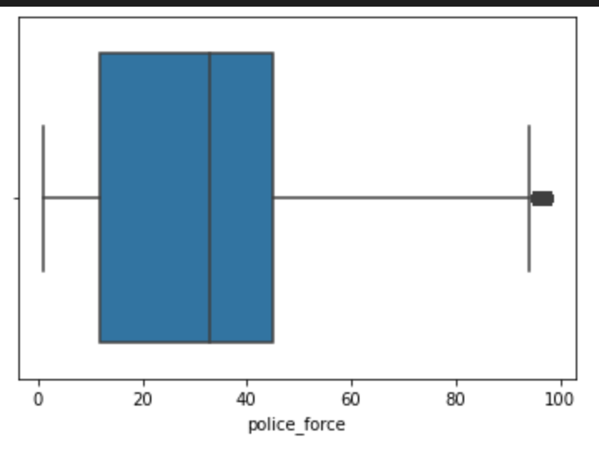

Fig: Box plot showing outliers in Police Force column

# Descriptive Analysis

We have cleaned the names of the columns for easier use in code:

1. We replaced white spaces in column names with _

2. Converted all column names to lower case

Attached the full list in Appendix section

## Data Dictionary: -

### Numeric Columns:

Police_force: This is the number of police officers in a given area/ zipcode. Based on the plot below, we cannot identify any clear distribution of the police_force variable and it does not resolve any known distribution like, normal or multi-model. In the future, during Week -5, we will try to transform it using log transformation or box-cox transformation.

The statistics for these numeric values are:

count 478741.000000

mean 31.610178

std 24.941660

min 1.000000

25% 12.000000

50% 33.000000

75% 45.000000

max 98.000000

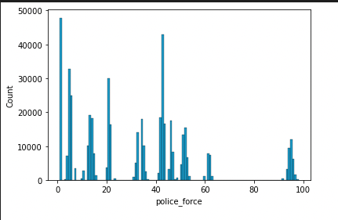

Fig 1. Histogram plot for police_force

### Categorical Columns with brief look:

To be safe we have used pd.Categorical to type cast all the categorical columns.

1. number_of_vehicles: this is categorical, with 4 categories (1-4)

2. day_of_week: which day of the week is it, Monday, Sunday?

3. 1st_road_class: It has 8 classes.

4. road_type: There are 6 types of roads and 1 is unknown.

5. speed_limit: 6 classes (20-70)

6. 2nd_road_class: 5 classes

7. pedestrian_crossing_human_control: 3 classes/types

8. pedestrian_crossing_physical_facilities: 6 classes

9. light_conditions: 5 classes

10. weather_conditions: 9 classes and 1 is unknown

11. road_surface_conditions: 5 classes

12. special_conditions_at_site: 8 classes

13. carriageway_hazards: 6 classes, most of them are NONE

14. urban_or_rural_area: (1 or 2)

15. did_police_officer_attend_scene_of_accident: Yes or No values

16. state: 3 types

17. postcode: A lot of postcodes

18. Local_authority_highway_

19. Local_authority_district_

**The graphs for categorical values are in the appendix**

### Date columns:

1. date

2. day_of_week (also categorical)

3. Time

We will be deleting the date, as it is not important in our analysis, we will use time by doing feature engineering where define a new column that groups the Time the accidents happened into one of five options:

Morning Rush: 5am to 10am 🡪 value 1

Office Hours: 10am to 3pm (or: 10:00 - 15:00) 🡪 value 2

Afternoon Rush: 3pm to 7pm (or: 15:00 - 19:00) 🡪 value 3

Evening: 7pm to 11pm (or: 19:00 - 23:00) 🡪 value 4

Night: 11pm to 5am (or: 23:00 - 05:00) 🡪 value 5

### Target column for predictive analysis:

number_of_casualties: it is categorical (1-5) or numeric

### Hypothesis for our predictive work:

1. Increase in number of vehicles can increase the # of casualties.

2. Day of week, weekdays are mostly busy days and may lead to a lot of accidents and casualties.

3. Date and time are separate columns; the time column can be interesting since most accidents can happen between certain times (like office hours).

4. The speed limit can influence the number of casualties.

5. road_type can have an effect (hair pin 🡪 more accidents 🡪 more casualities)

6. light_conditions; dim light may affect the driver and in turn lead to accidents.

7. weather_conditions, rainy days and snowy days can lead to accidents.

8. road_surface_conditions may lead to some mishaps and casualties.

9. special_conditions_at_site (will need to look at the conditions before using it for decision making).

10. carriageway_hazards may have an influence on the accident.

11. urban_or_rural_area, rural areas have comparatively less traffic!

12. did_police_officer_attend_scene_of_accident as they could save lives and the column can be interesting to explore from data and to see what the effects were.

13. postcode: We will see if it helps in identifying if a particular area has more accidents due to the climatic conditions or more drug usage area etc.

## Missing Values:

As reported in the previous section, we have a few missing values, (529 in total). It is less than 0.1% of our data, so we are planning to drop the missing values for a cleaner analysis.

## Outliers:

As reported in the previous section, there are outliers only in the police_force column and we may be eliminating these outliers. In case we end up using tree-based methods, which are robust to outliers, then we will retain and use the outlier data points during predictive analysis.

## Type conversion:

All categorical columns would be explicitly converted to categorical data type in python using pandas’ Categorical function at data cleaning stage.

## String manipulation:

No text data

The bar graphs for categorical values are in shown below:

1. number_of_vehicles
2. day_of_week
3. road_type
4. 1st_road_class
5. pedestrian_crossing_physical_facilities
6. speed_limit
7. pedestrian_crossing_human_control
8. light_conditions
9. weather_conditions
10. road_surface_conditions
11. special_conditions_at_site
12. carriageway_hazards
13. urban_or_rural_area
14. did_police_officer_attend_scene_of_accident
15. state

The first line in every picture Graph provided below includes the information of the graph including the title of the graph, x – axis and y – axis used. At the end of all the graphs, the insights of all the categorical variables are present. All the graphs are self-explanatory and indicate various categories for each feature.

All the Categorical Variables are Nominal Categorical Variables except for the 2 variables, and they are:

1. urban_or_rural_area : indicates if the area of the accident is rural or urban, urban is 1 and rural is 2
2. did_police_officer_attend_scene_of_accident: indicates if the police officer attended the scene of the accident or not (yes or no values)

Fig: Bar chart showing number_of_vehiles(categories 1-4) involved with accident count

Fig: Bar chart showing accident count as per day of week data

Fig: Bar chart showing accident occured on different road type

Fig : Bar chart showing roads owned by the state government

Fig : Bar chart showing count of Pedestrian_Crossing through physical barriers.

Fig : Bar graph showing count of speed limit on roads.

Fig : Bar chart showing count of Pedestrian_Crossing within human control.

1. 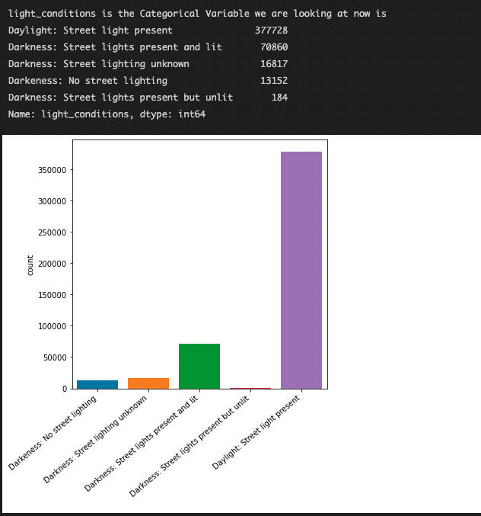

Fig: Bar chart showing accident occurred in different light conditions.

1. 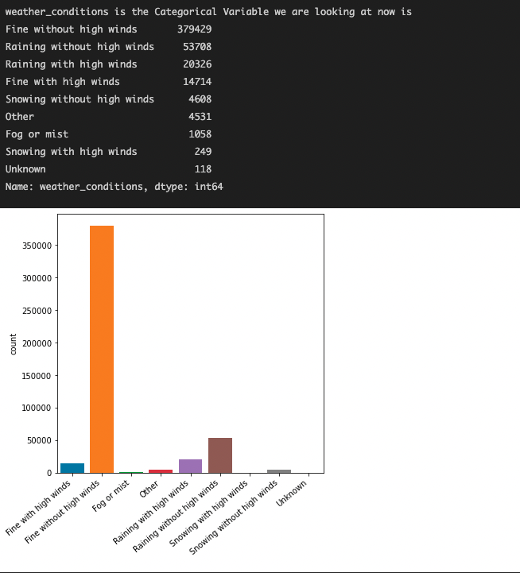

Fig: Bar chart showing accident occurred in different weather conditions.

1. 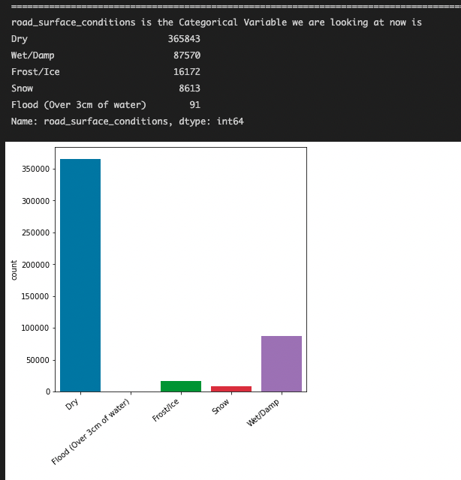

Fig: Bar chart showing accident occurred in different road surface conditions.

1. 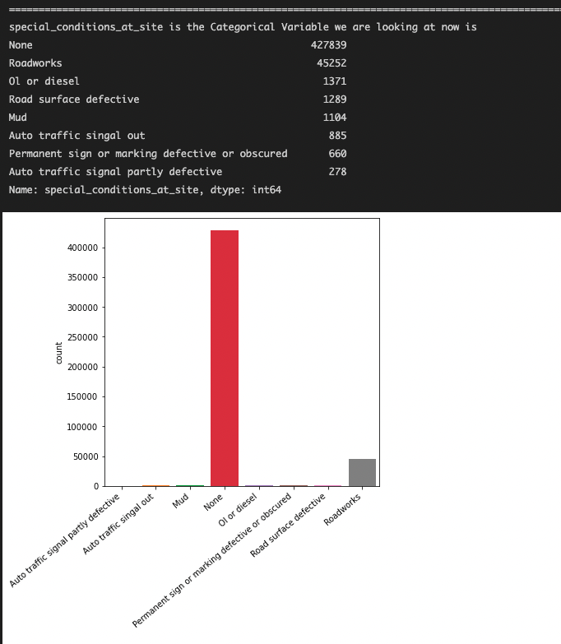

Fig: Bar chart showing accident occurred in different special conditions at site.

1. 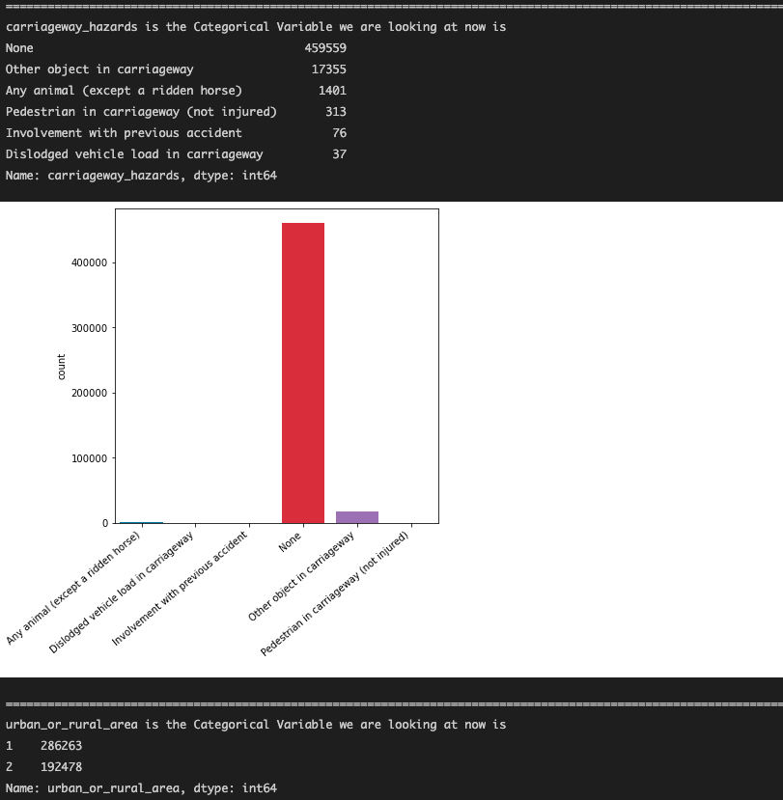

Fig: Bar chart showing accident occurred due to different carriageway hazards .

1. & 14.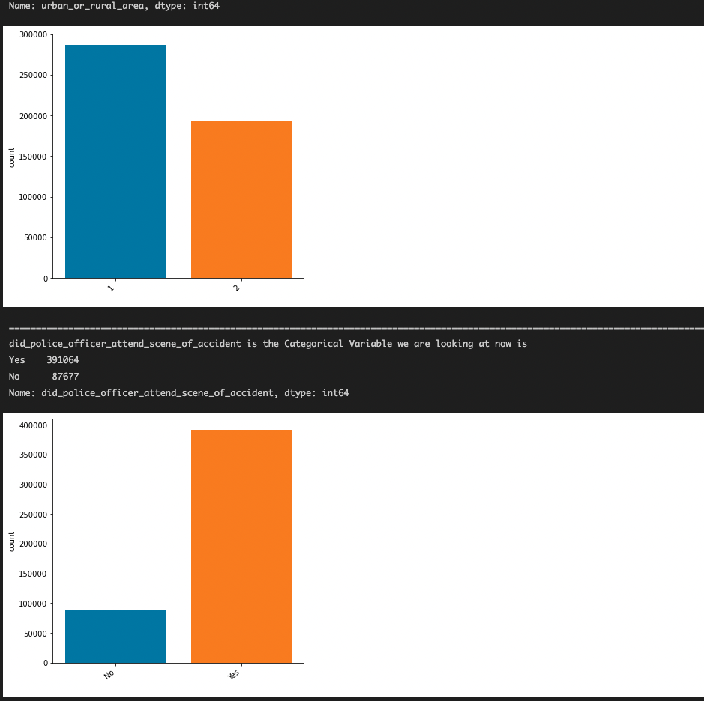

Fig: Bar chart showing accident occurred in urban-rural areas and how many times police officers attended the scene.

15. 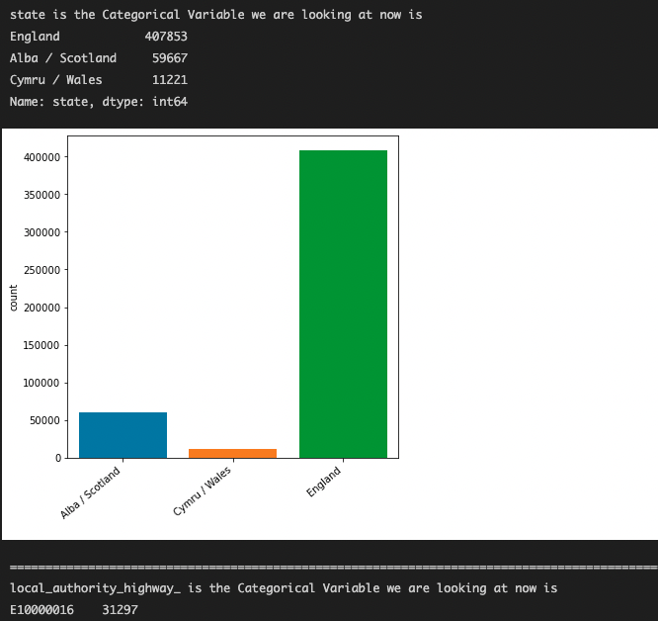

Fig: Bar chart showing accident counts in different states

### Explanation of Categorical attribute’s Data - :

Overview about the type of information contained inside the categorical attributes of our dataset.

1. number_of_vehiles: Data mostly is about when there were 2/1 vehicles involved. This can be used for modelling.

2. day_of_week: Most of the data is recorded about 6 (Saturday) followed by categories

3. 1st_road_class: most belong to 3 and 6

4. road_type: Most belong to Single carriageway, followed by Dual carriageway (last 2 can be grouped together)

5. speed_limit: Most of the data says 30mph (329800) is the speed limit

6. 2nd_road_class: Most of the data is about the category -1 and 6

7. pedestrian_crossing_human_control: Most values (None within 50 meters), controlled by other authorized person (second most), 3rd very less

8. pedestrian_crossing_physical_facilities: No physical crossing within 50 meters, 404561.

9. light_conditions: Most of the days (Daylight), next, Darkness: Street lights present and lit.

10. weather_conditions: Most of the days were fine without high winds, next highest (Raining without high winds, 53708)

11. road_surface_conditions: Most roads were dry, wet/damp (next highest).

12. special_conditions_at_site: Most of them have the value None and few not none (If not none, check how it affected the casualties).

13. carriageway_hazards: Most of them were None (If not none, check how it affected the casualties).

14. urban_or_rural_area: Nearly equal (1 is slightly higher).

15. did_police_officer_attend_scene_of_accident: Most of them were Yes.

16. state: Most of them happened in England

Correlation Among Categorical variables

For finding how our categorical variables are correlated with our target variable we will be using a library called dython.

After applying the necessary associations function on our dataset we get

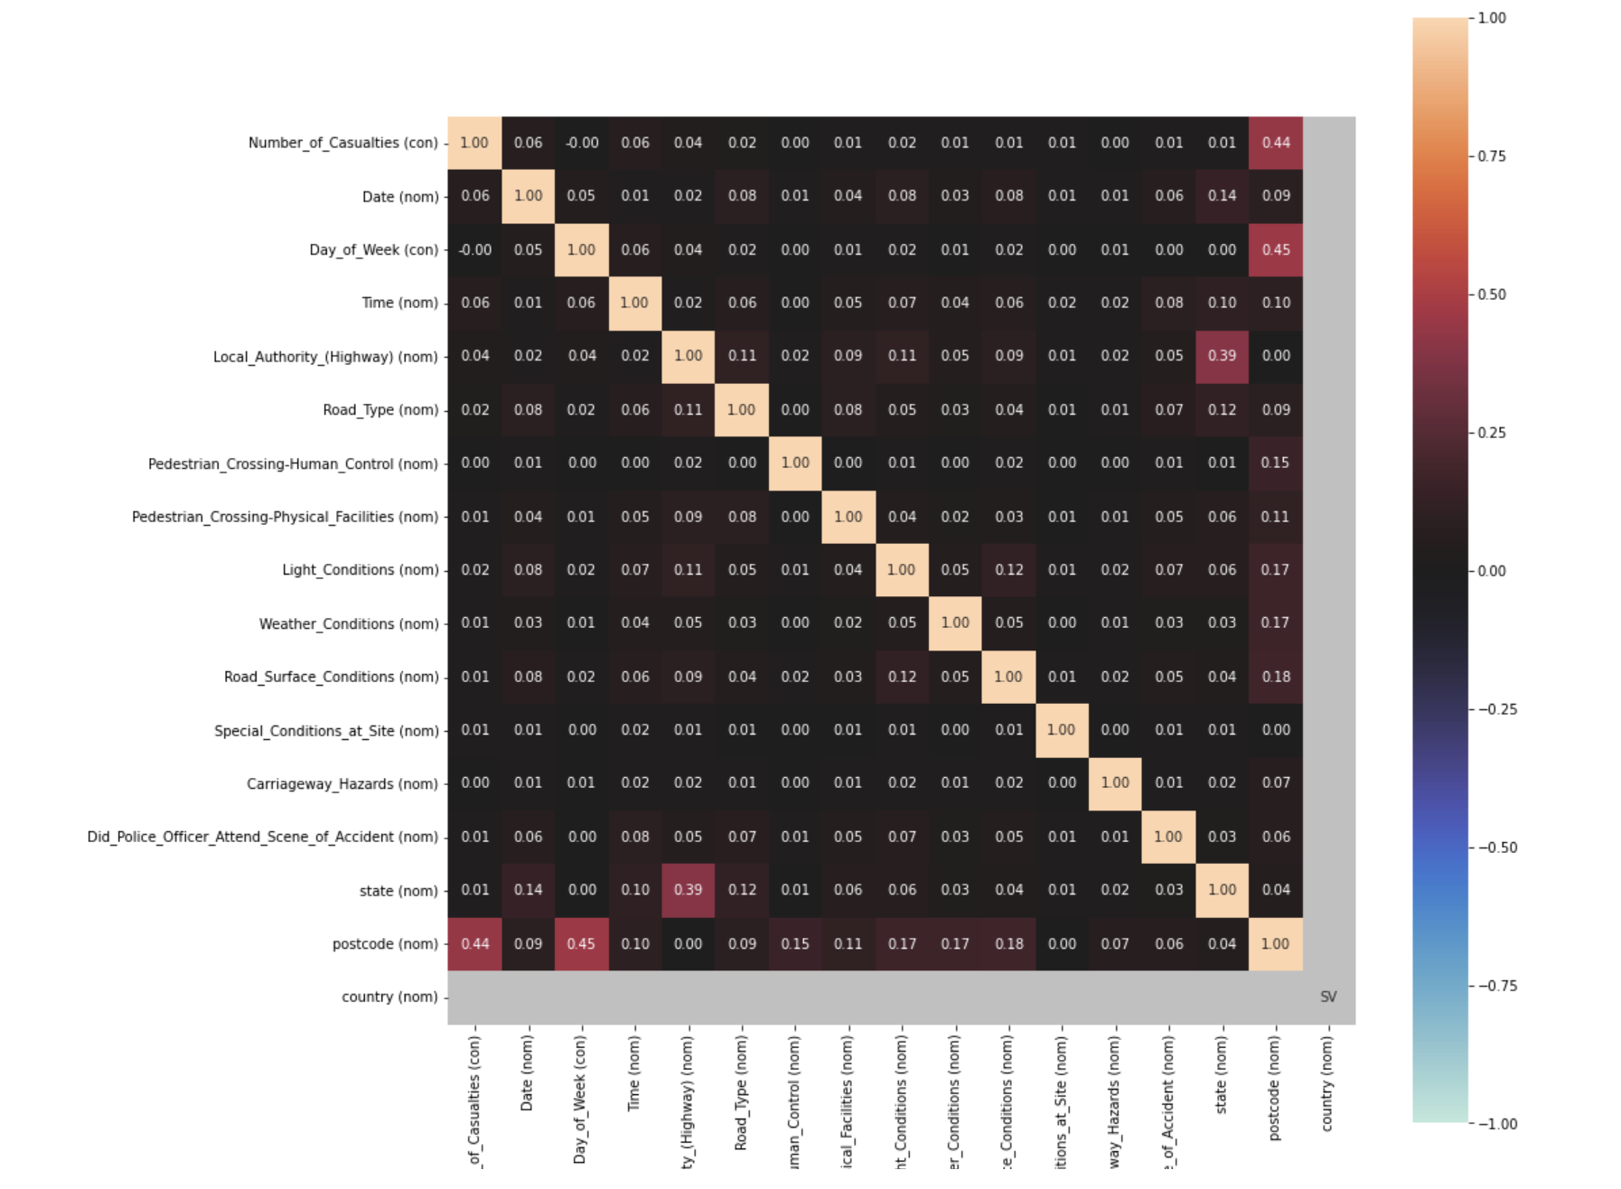

Fig: Correlation matrix within categorical variables

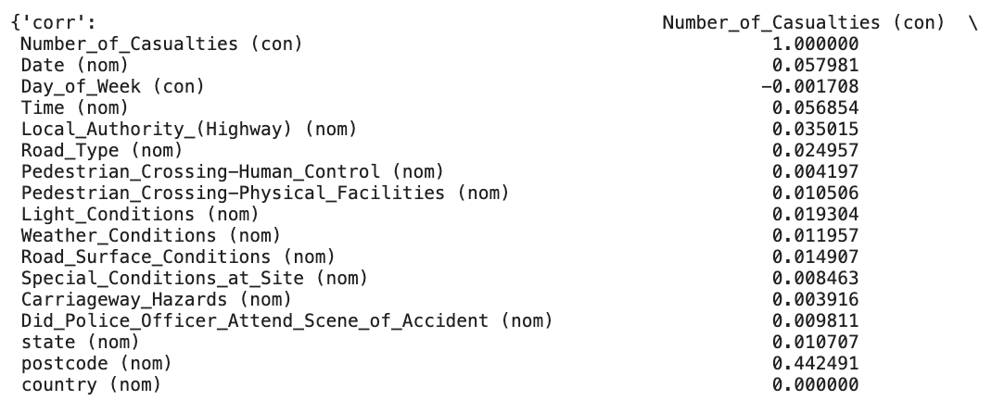

We can see that the correlation values of categorical variables with respect to number of casualties are clustered near 0. This indicates that there is almost no correlation among our categorical variables and target variable. We see a correlation of 0.44 between number of casualties and post code.

**Descriptive Question Answering:**

1. Which of the two conditions (lighting or weather) had a serious impact on the accidents?

**Light Conditions:**

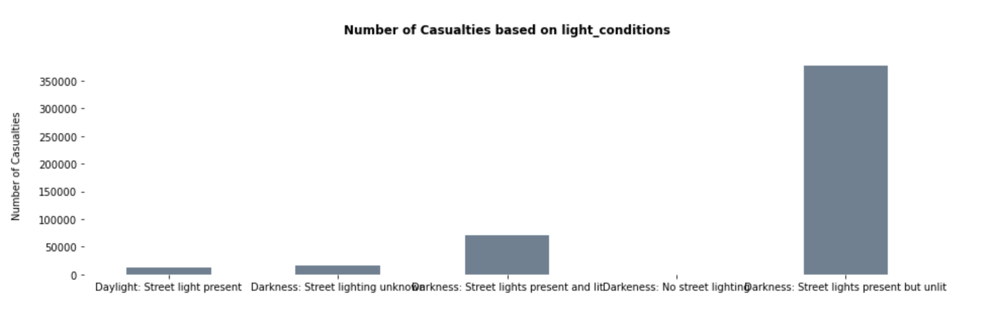

Fig showing Numer of casualties based on Light Condtions

We see that the light conditions when “street lights present but unlit” lead to a lot of casualties. This also makes pratical sense since unlit roads are difficult to navigate (sometimes even with headlights on vechile).

**Weather Conditions:**

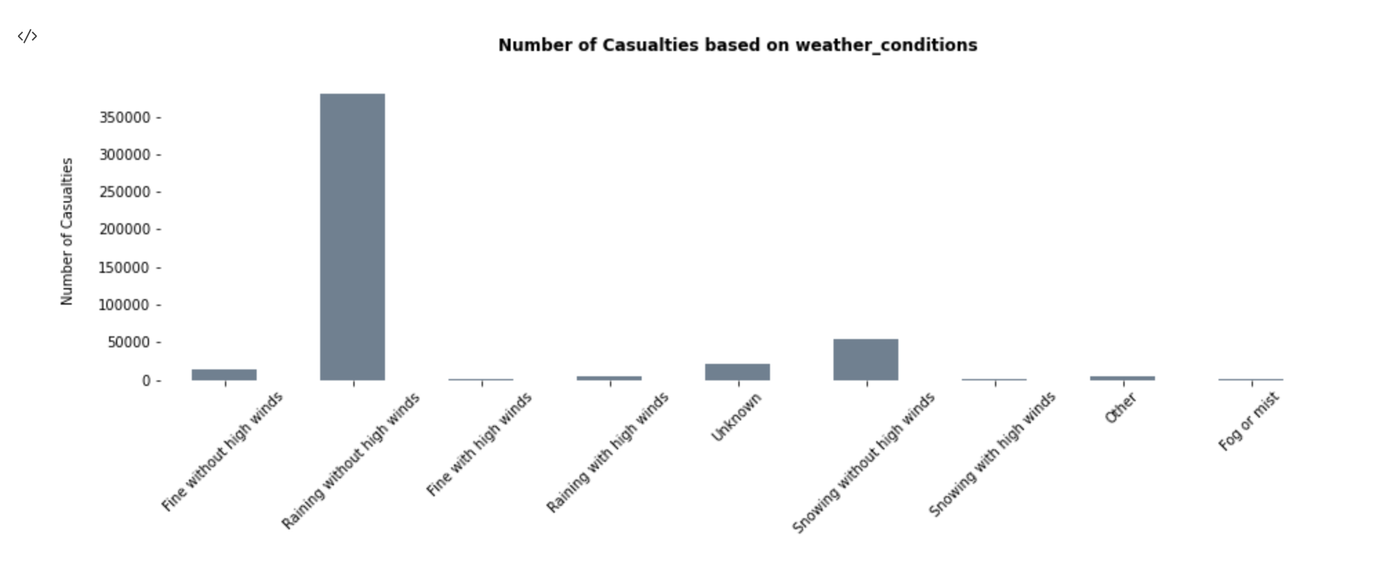

We see that the weather conditions when “Raining without High Winds” lead to a lot of casualties. This is intreseting as Raining with High Winds has lesser casualties. Our reasoning is that with Rain with less winds there are still lot vehicles on road and the rains could make road slippery and can cause some visibility issues to drivers which could lead to accidents and casualties.

Between Light Conditions and Weather Conditions there are particular category of conditions under which we see high casualties

1. What are the regions or areas with the most frequent accidents?

Following lists the top 10 post codes/areas in United Kingdom with most frequent accidents:

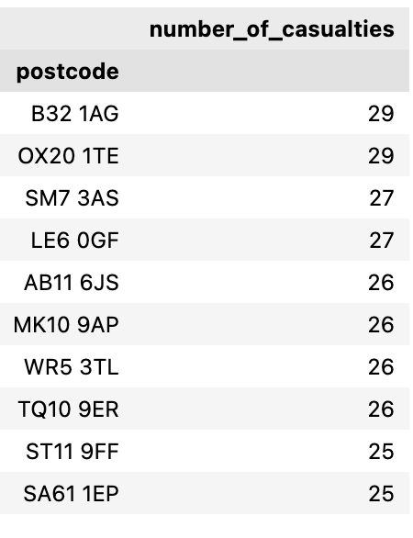

# Data Cleaning and Progress Report

# Introduction:

The goal of our data driven analysis project is to provide solutions to our target audience, the Ministry of Transportation, to the business questions we analyze related to accidents on the road. Data-Driven Decision-Making Algorithms and Methods are used to facilitate conducting a comprehensive analysis of past accidents and gaining insights into what caused these incidents as well as to establish a framework that can be used to avoid these catastrophic events to a large extent using data-driven methods and algorithms. This analysis will attempt to establish a framework which can be used to take measures to prevent these catastrophic incidents to a great extent.

At this point in the project, we have established the business questions we want to address and also identified our target audience (the Ministry of Transportation). Hours long of brainstorming has been conducted at this time and the project proceeds to be heading in line with our expectations. We have until now also completed the data collection and descriptive analysis stages. We have held back our analysis of the descriptive part as we will be visiting it when we clean and more importantly transform some of our data.

The data we have found has been used by a car insurance company in the past for their policy creation and no other details are revealed about the use of the data. This point is being made here as we just recently discovered this fact and also our data is reliable. A reliable data is which can be trusted and comes from a trusted source and given the nature of our project, this boosted our confidence of success. The dataset we are working with comes from the UK government’s Department of Transport and has been approved with a [Open Government License](https://www.nationalarchives.gov.uk/doc/open-government-licence/version/3/). With all these points in mind we can say that our data is maintained well and is reliable and free to copy, publish, distribute and transmit as per use (as mentioned in [Open Government License](https://www.nationalarchives.gov.uk/doc/open-government-licence/version/3/))

In the coming days we will be cleaning up our data and removing the missing values. We don’t see the need to perform any other cleaning at this point. Subsequently after data cleaning we will be transforming our data. We will also create a new variable of time category from time column as mentioned in the descriptive section (subsection Date Column). The most important ones to be transformed are the date and time columns as we want to establish windows during which accidents take place. As mentioned in the earlier sections we will subsequently experiment to test our hypothesis on the cleaned and transformed data.

Once we perform the above-mentioned data wrangling, we will be ready with a dataset that will help us answer our business queries:

For descriptive analysis we will be look at the:

1. Average and count of accidents that happen in certain lighting, weather and road types. We will also look at certain segments of time and day of the week where the accidents mean, and count is high/low.
2. We will aggregate the count based on pincodes to see which areas see the most accidents. We will also do a mean reporting of the accidents. As our data has a very high number of unique pincodes, the report will contain the list of top k pin codes /areas with most accidents. (k will be discussed over with the team and also inferred from data and reported)
3. For predictive analysis we will be trying to predict the number of casualties and test the model against the test set we have. We will use the k-fold cross validation method and RMSE as the metric for our predictive model. We have a holdout test set to further test our model. Hyper-parameter tuning will also be done with a validation set created.   
     
   We also plan to introduce an accident index which is defined by   
     
   *accident_Risk_Index (mean casualties at a postcode) = sum(Number_of_casualities)/count of accidents at the postcode*  
     
   This index should indicate the causality at a given postcode. More on this will be expanded through empirical results.  
     
   The code to do it is present in the Appendix section (Creating the accident risk index)
4. The prescriptive analytics will be conducted once we have addressed the above 3 steps. This part will be elaborated in the coming days.

**Backup plan**:

1. To develop on the approach followed by Abdishakur for data transformation, data preprocessing and use random forests to predict the number of fatalities based on the attributes of the crash dataset (<https://towardsdatascience.com/predicting-vehicle-accidents-with-machine-learning-ce956467fa74> )
2. With the help of Convolution Neural Networks build a system to predict the number of accidents based on geographical distribution as added input to help with the exact locations. This can also help the government and local road authorities looking to create more efficient systems of road maintenance and improvements based on the predicted accident locations. (<https://github.com/L-Lewis/Predicting-traffic-accidents-CNN> )

## METHODS:

Our dataset has few missing values, which are as follows:

The time column which shows time of accident is having 14 null values, the road_surface_conditions which shows if the road has any pothole, cracked pavements has 452 null values and special_conditions_at_site which shows anything special happened on the road (like a lockdown) or another accident or a sudden intrusion has 63 nulls. The null values can be removed from the dataset as its ratio is comparatively low with respect to overall data. Below is the summary for missing values in our dataset.

|  |  |
| --- | --- |
| **Column** | **Missing count** |
| time | 14 |
| road_surface_conditions | 452 |
| special_conditions_at_site | 63 |

As reported in the previous section, we have a few missing values, (529 in total). It is less than 0.1% of

our data, so we are planning to drop the missing values for a cleaner analysis. The only data cleaning we have agreed upon doing is removal of missing values and dropping some columns. So, we used pandas to help us with the missing values where we used the dropna method with the argument axis=1 and inplace=True to remove the data from the dataframe.

We won’t be removing the outliers for now and the reason being we will be using tree-based models for our predictive modelling and they are very robust to outliers and removing them thus doesn’t make any sense. Since we are not removing the outliers, we do not represent any method for outlier pruning. Just for better understanding and visualization, we have represented that Police Force column has this distribution of outliers

There are just a couple of outliers present for the Police Force column



Fig: Box plot showing outliers in Police Force column

**Columns being dropped and reasons for dropping them**

1. **1st_road_number**: Most of the columns have the same value. So the values here are static and we are removing the column since it doesn’t help in any analysis.

2. **2nd_road_number**: Most of the columns have the same value. So the values here are static and we are removing the column since it doesn’t help in any analysis.

3. **Accident_id** : Because it is a unique ID to record the accidents number. This is being dropped after creating the accident index. It doesn’t help in any analysis.

4. **Country**: It is constant as we got the entire data from the accidents in United Kingdom. So the values here are static and we are removing the column since it doesn’t help in any analysis.

### 

### EXPERIMENTAL SECTION:

We have removed the 529 observations which constitute hardly 0.1% of our data. The removal of the data doesn’t change any distribution. Attaching a brief report of before and after the data removal count.

**Transforming the time :**

Following is the function which is self-explanatory which helps in transformation of time data as outlined in descriptive section:

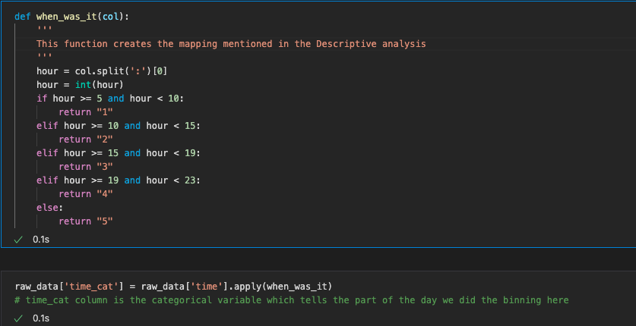

Fig : Function for time data transformation

Using the above function we create a new column called as time_cat column which is categorical in nature and tells the time of the day when accident happened. We used the concept of binning here.

**Missing columns before data removal:**

There are some missing values in various attributes of our dataset. The time attribute has 14 missing values, the road surface condition has comparatively a lot of missing values. Although there are missing values in the dataset it still accounts to less than 0.1 % of data and hence for cleaning the data we will be removing these values.

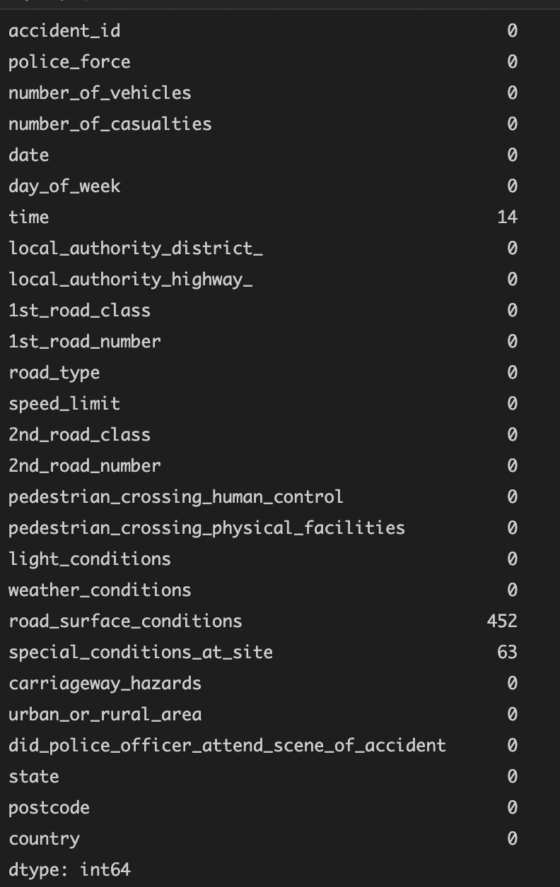

Fig: Count of missing values per column

# Result:

**After removing the missing data, deleting the unrequired columns and creating time_cat variable:**

As we can see in the below picture, we removed all the missing values from our dataset and cleaned the dataset which will help us in effectively providing solutions to the stakeholders with high efficiency. We also deleted the columns we identified don’t help in analysis. We also created time_cat a better representation of time feature for descriptive and predictive analytics.

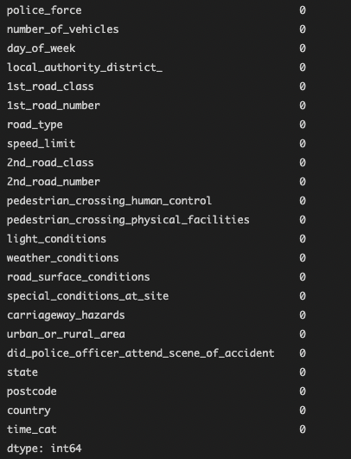

Fig : count of missing values per column post removal

# Data Transformation

## METHODS:

**1. Variable Selection**

Since most of the variables as shown in descriptive analytics are important and play a significant role in predicting the number of casualties (dependent target variable), we will be including all the variables except the ones mentioned below.

We are removing country variable as the dataset consists of data only from UK, hence it is of no use to have same value for all rows as an input independent variable. We are also removing '1st_road_number', '2nd_road_number' as most of the values across rows are similar and it does not play any significant role. We will also be dropping accident_id but only once we have used it to compute our feature engineered variable “accident_risk_index”, as discussed in the next section.

Therefore the final list of variables that are selected are:

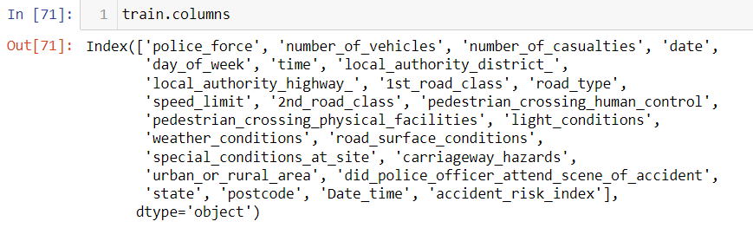

A brief explanation of why these variables might be able to answer to our predictions of number of casualties:

1. Increase in number of vehicles can increase the # of casualties.

2. Day of week, weekdays are mostly busy days and may lead to a lot of accidents and casualties.

3. Date and time are separate columns; the time column can be interesting since most accidents can happen between certain times (like office hours).

4. The speed limit can influence the number of casualties.

5. road_type can have an effect (hair pin 🡪 more accidents 🡪 more casualities)

6. light_conditions; dim light may affect the driver and in turn lead to accidents.

7. weather_conditions, rainy days and snowy days can lead to accidents.

8. road_surface_conditions may lead to some mishaps and casualties.

9. special_conditions_at_site (will need to look at the conditions before using it for decision making).

10. carriageway_hazards may have an influence on the accident.

11. urban_or_rural_area, rural areas have comparatively less traffic!

12. did_police_officer_attend_scene_of_accident as they could save lives and the column can be interesting to explore from data and to see what the effects were.

13. postcode: We will see if it helps in identifying if a particular area has more accidents due to the climatic conditions or more drug usage area etc.

**2. Feature Engineering and Transformation**

The process of changing raw data into features that better describe the underlying problem to predictive models, resulting in enhanced model accuracy on unseen data, is known as feature engineering. Here are some steps we followed for Feature Engineering:

1. Brainstorm features.
2. Create features.
3. Examine how the features interact with the model.
4. Restart from the beginning till all of the functions are fully functional.

We brainstormed two features to add to our dataset namely “Accident_Risk_Index” and “time_cat”. The “Accident_Risk_Index” indicates a risk index for accidents and its the number of casualties divided by the number of accidents. Moreover, “time_cat” is a categorical variable which maps specific time periods in which the casualties occured. For eg.

5am - 10am was mapped to 1

10am - 3pm was mapped to 2

3pm - 7pm was mapped to 3

7pm - 11pm was mapped to 4

11pm - 5am was mapped to 5

Below is the code implementation of the feature engineered variable:

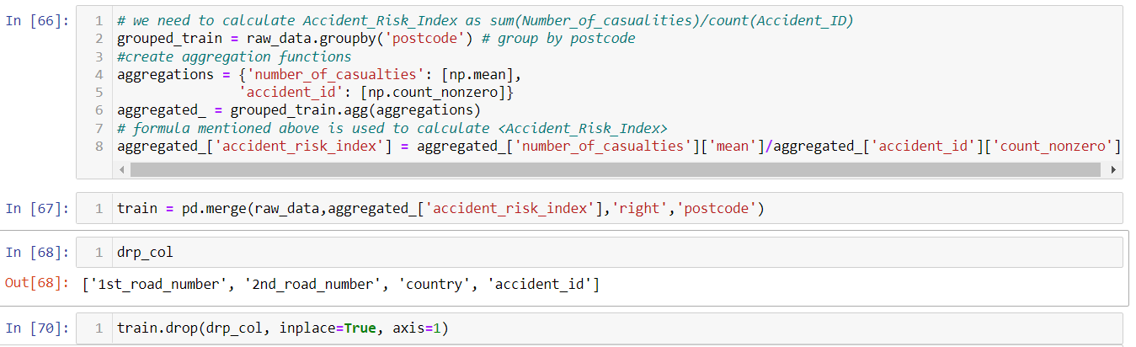

The first transposed row of newly created dataframe is as follows:

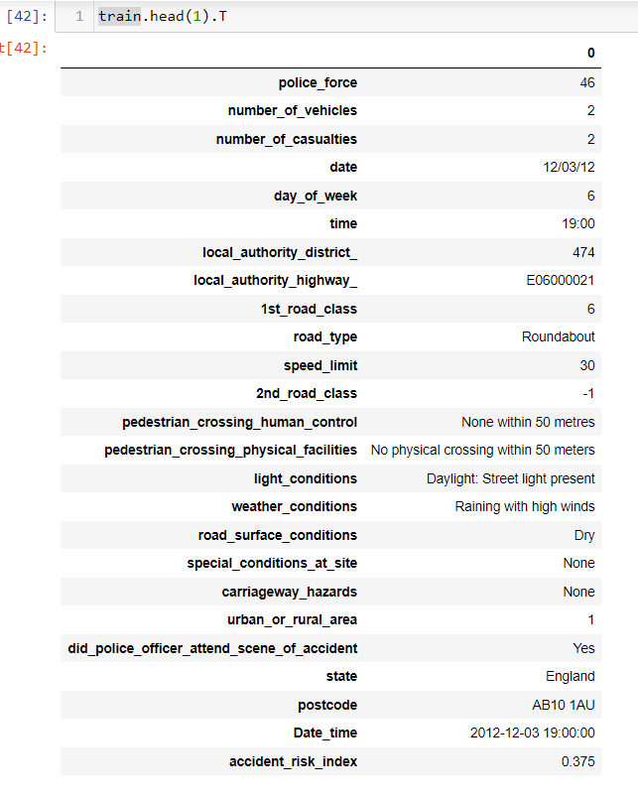

One hot encoding is a process by which categorical variables are converted into a form that could be provided to ML algorithms to do a better job in prediction. But one downside of using One Hot encoding is that it will lead to explosion of variables and will increase the number of variables for modelling. As an alternative this we will be using Label Encoder.

A Label Encoder uses the label encoding technique which assigns categorical variables a numeric value. For example, if a variable has 3 types consider color : Red, Blue and Green. The Label encoder will assign each category a numeric value like Red: 1, Blue: 2 and Green: 3. We do this to our categorical variables since most machine learning algorithms can’t work with string/text data.

In this next screenshot we are demonstrating how we are using Label Encoder to Encode all of our categorical variables. One advantage of this method is that it won’t lead to an explosion of variables and the modelling won’t be bombarded with explosion of predictor variables.

With Label Encoding we may be see an issue because the models may confuse the values of labels (1 , 2, 3 and so on) to have some ordinal meaning where as they really don’t have any such meaning. This is a bias that gets introduced with this approach. But [5] shows that Label Encoder can be used instead of the One Hot encoding when we have a lot of Categorical Columns.

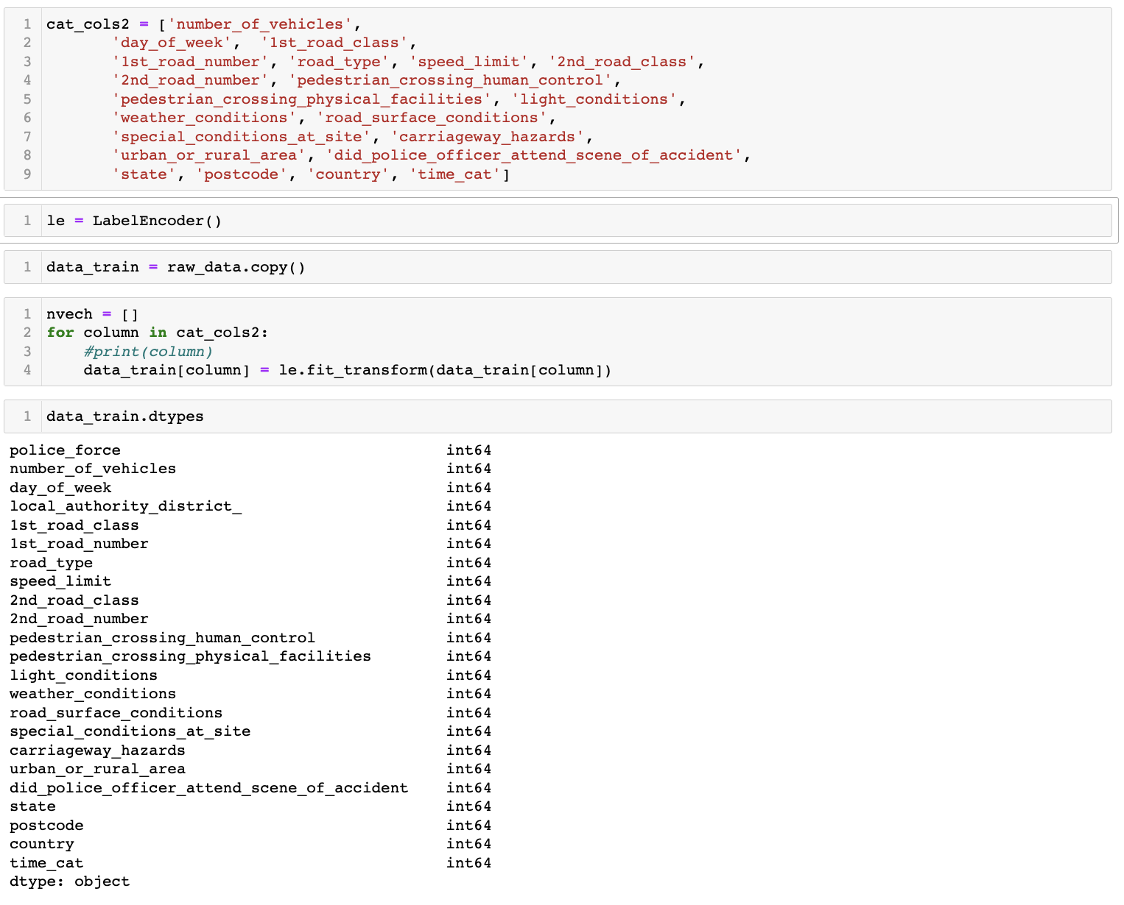

Now we can see that all of our variables are in a integer format as expected by modelling algorithms.

**3. Data Reduction**

PCA is a well-known method for data reduction. Some of the use cases where data reduction (PCA) comes handy is when:

1. We have to reduce the dimensionality of the data
2. Data reduction helps in simplifying the model which can lead to actionable results.
3. It also helps reduce the correlation amongst the variables.

Although, in our case we are not reducing the data and not applying techniques like PCA because:

1. The independent variables in our dataset have very less to no correlation with the dependent variable (number of casualties )
2. We also want to avoid the tradeoff between information loss and dimensionality reduction.
3. We also want to avoid the loss of interpretability that is associated with principal components.

Although, we have manually dropped few columns which we felt are not fruitful as predictor variables for our dependent variable as mentioned in variable selection under methods.

**4. Approach**

We will be using our data to create a model which is capable of predicting the number of casualties. First, we will be splitting our data into training and testing subsets. We are sticking to 70:20:10 split (train: validation: test). The training dataset will be used to train the models and the testing dataset will be used to test how well the model performs on the task of predicting the number of casualties. For validation we will be using 20 % of train dataset and use 10-k fold cross validation as our strategy to test the validity of our models and also the 10-k fold cross validation fold will help us in our hyper-parameter tuning. By using 10k-fold cross validation we are avoiding sampling error which can lead to a false metric after the model training. (For example: Consider the scenario of dataset which has 3 classes and if the validation split gets datapoints with just 2 classes then we have a sampling error. )

As we have a regression use case, some of the Machine Learning model we will be training for our use case are:

**4.1. Linear Regression**

Linear regression is a statistical method for modeling the connection between a scalar response and one or more explanatory factors. Linear regression is used when there is only one explanatory variable; multiple linear regression is used when there are more than one.  
  
We start with Linear Regression to setup a baseline for our work and then use advanced modeling algorithm of increasing complexity.

**4.2. Random Forest Regressor**

Random Forest Regression is a supervised learning technique that does regression using the ensemble learning method. The ensemble learning approach combines predictions from numerous machine learning algorithms to get a more accurate forecast than a single model. In the case of Random Forest, multiple Decision Trees are used for ensembling. Using this tree-based approach results in automatically pruning of outliers from the input data. To avoid overfitting in our Random Forest model we will be tuning the hyper-parameters of the algorithm (for example the number of samples in the leaf) with the help of RandomSearchCV /GridSearchCV as discussed below.

**4.3. AdaBoost Regressor**

An AdaBoost regressor is a meta-estimator that starts by fitting a regressor on the original dataset and then fits more copies of the regressor on the same dataset, but with the weights of the instances changed based on the error of the current prediction. This helps us optimize the current model by considering the errors of each previous fit.

**4.4. Hyperparameter Tuning**

We also plan to use hyperparameter tuning techniques such as GridSearchCV or RandomSearchCV to optimize the parameters of our models.

The model which performs the best among Linear Regression, Random Forest Regression, and AdaBoost Regressor will be considered for hyperparameter tuning and then we will be finalizing the model which performs the best among all these experiments.

## Approach

After performing systematic data analysis to study the conditions that have an impact on the accidents, we move on to testing models to predict casualties in advance that will only aid the general public, but also help ministry of transportation in taking preventive steps to minimize these accidents in the future. To predict these accidents well in advance we will start building our model with a very well-known approach in the linear models i.e., linear regression.

Linear regression is one of the most commonly used and highly interpretable statistical machine learning modelling method.

Once we are done with the Linear model, we move to a more complicated model and introduce Random Forest (RF). Random Forest is a tree-based approach, in which multiple decision trees are built (hence the name forest). Each tree uses a subset of data and builds multiple weak decision trees. Random Forest has been proved a go-to and state of the art modelling for tabular data (look at winners of Kaggle competitions on tabular data).

Once we are done with Random Forest, we want to use the AdaBoost Algorithm. It is a boosting algorithm which mostly uses decision trees like Random Forest, but the Adaboost algorithm is based on the boosting principles which helps in building better decision trees over each iteration of building a model.

To summarize in our approach, we start with a Linear Model, assuming the linear assumptions between dependent variables and independent variables (number of casualties), which will be a baseline model for our more complex Random Forest and AdaBoost. If the Random Forest and Adaboost perform better than linear regression, only then, we fine tune the best model among these. The approach of building a baseline model and if a complex algorithm beats it, it is a good reason for us to move on to introducing complex modelling and fine tuning. We will also keep an eye on over fitting.

## Experimental Methods:

We have established that we are building 3 models (Linear Regression, Random Forest and AdaBoost). We will rely on the amazing low code ML package pycaret to build our models. Pycaret is a low code ML library which is great to start your modelling.

We start by splitting our data into train and test (80: 20 ratio). We use 10-k fold cross validation on our training data (again here 80% of train data is used and 20 % is used for validation and parameter tuning). Based on the best model obtained we will do fine tuning.

[4] Pycaret has an API function to complete the tasks, so we use the setup function from pycaret. The setup function takes the data and does any transformation if needed (like if you want to remove outliers, do PCA, transform the target variable and many more, additional info present in appendix). Since we did it earlier in last 2 submissions none of these are applied in our method.

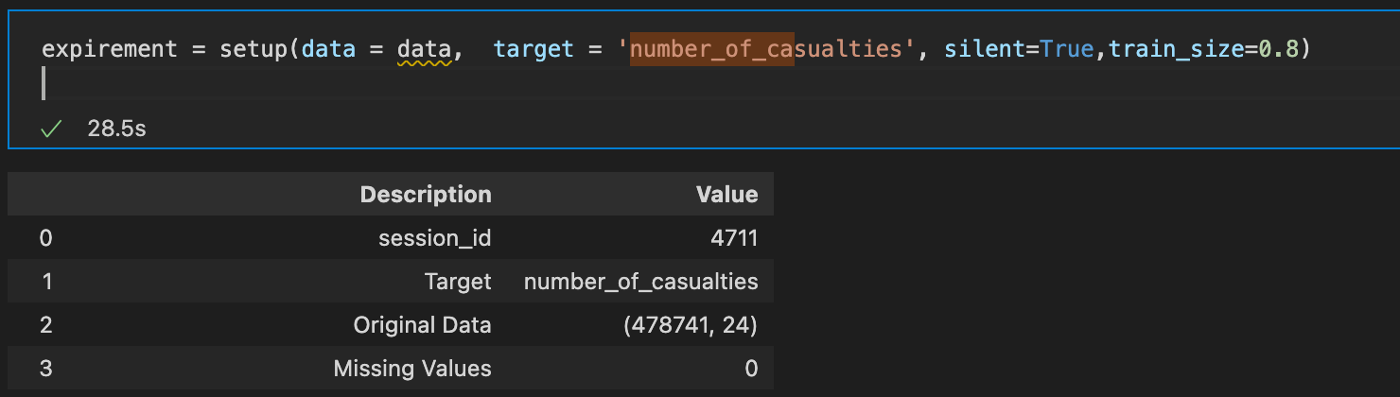

Fig **Code Snippet for pycaret setup**

Pycaret setup also has data to pass our data and train size to make sure of the train size we want to retain (we mentioned 80:20 split hence passed train size =0.8.)

Some other things about training set and test set that pycaret verifies:



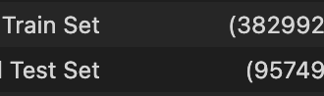

Fig Quick validation of data

We have handled our data by cleaning and transforming it earlier.

We will be using RMSE for our model evaluation as mentioned earlier in the Introduction section (Data Cleaning section).

Now to actual modelling after quick validation on our data:

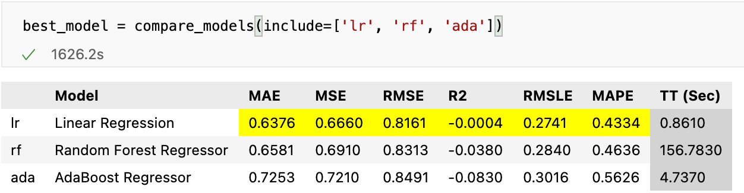

Tabel comparing our Predictive Models

We see that the best model we have is actually through our Linear Regression.

Let us fine tune the Linear regression a little bit and since there are not a whole lot of hyperparameters to tune we will be tuning if we need to normalize the dependent variables and do we need the intercept in our linear regression.

We use tune model method for fine tuning and later check the parameters of the best model.

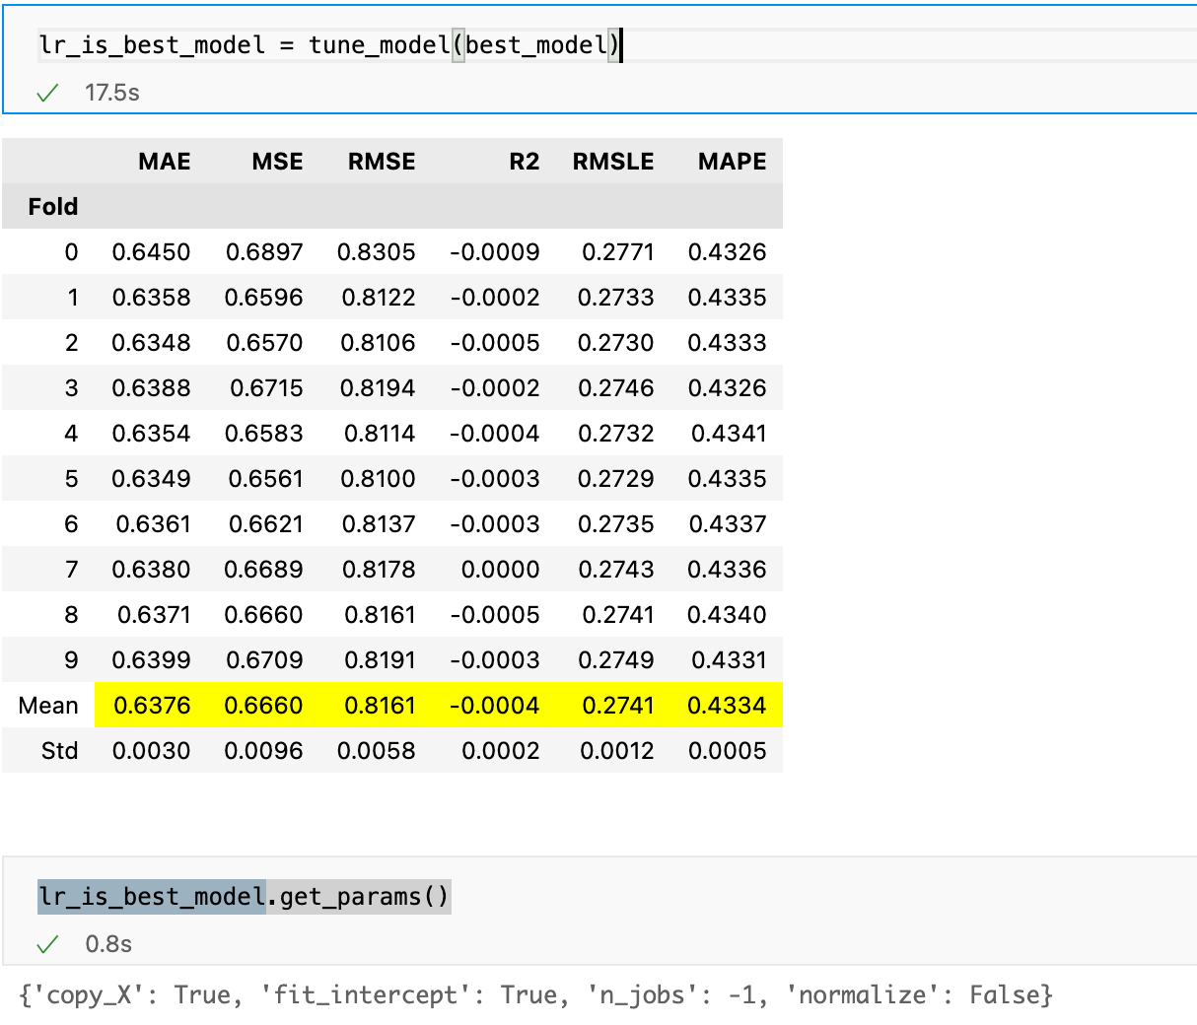

Table while doing hyperparameter tuning along with best hyper-params

We see the best hyper-parameter for our Linear Regression are:

1. We need the intercept.
2. No need to normalize the input dependent variables.

Let us now look our model’s performance on the test set. As mentioned pycaret has set aside the 20% of test set. We use the predict model method to get the performance on the test set.

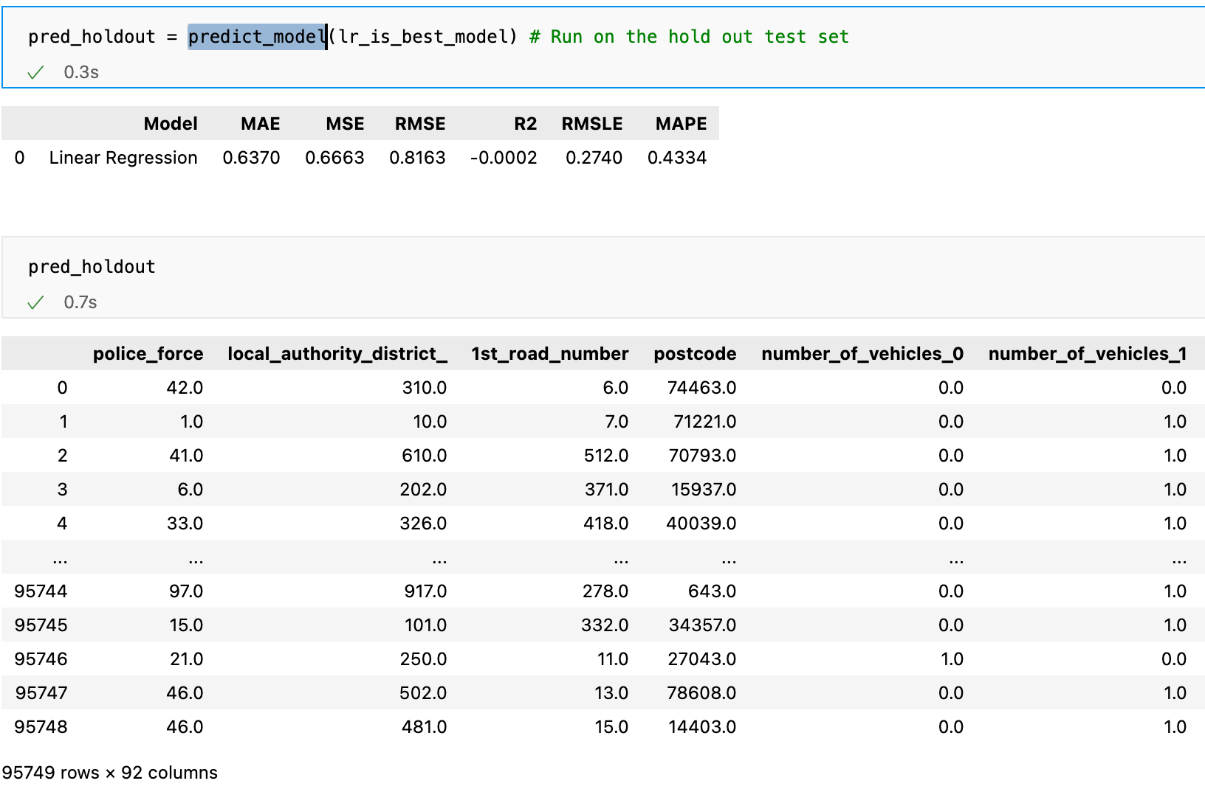

Test Set performance and the sample test set data frame

Some sample Predictions:

## 

Table Some sample prediction

## 

## Discussion

We have seen our report of performance on the three models. We have seen hyperparameter tuning and also, we have seen test performance of our best model.

One thing to address with our huge dataset and running 10k fold is that the complex models like Random-Forest and Adaboost take a lot of time per fold to fit as opposed to the linear model.

Random Forest took 156 seconds per fold for training and in total 1560 seconds (26 mins) for all the 10 folds.

Similarly, AdaBoost took 4 seconds per fold and 40 seconds in total.

Compared to these above 2 models Linear Regression takes just 0.8 seconds to run on each fold and accounting to less than 10 seconds to run for 10 folds. This is because Linear Regression model is a simple parametric model and converge faster on training set. This model giving us the best performance also trains faster giving us easy scaling capabilities.

One reason also that the RMSE is so low is because we are regressing on small values. We see that the RMSE the metric we chose for our project is best for Linear Regression. One more interesting thing to note here is that Linear Regression performed best on all of the other popular regression metrics (MSE, RMLE, R2, MAPE). This demonstrates that complex model is not always best and our hypothesis of Linear Regression being a baseline has been proved much more than that.

One argument can be made that the other two models also have similar measures for RMSE with Linear Regression being 0.816, RF being 0.8313 and AdaBoost being 0.8491. But the time spent in fine tuning these complex models won’t be any greater addition and also that these methods are relatively harder to interpret.

**Is our model overfitting:**

* Our 10k-fold mean for RMSE is **0.8161**
* Our test set performance of Linear Regression, RMSE is **0.8163.**

We see that the performance of the model on validation sets and the test set is similar. There is no way our model is overfitting and is performing fairly well on the task at hand.

The state of the art reported is around 0.65 RMSE which was discussed on a webinar hosted by [6] which was got by insurance company working on the data for over three years. In future work the lateral datasets mention earlier can be used to include and integrate even more features and improve the model.

**Interpretation of the Linear Regression Model:**

Let us take a look at our **Feature Importance Plot:**

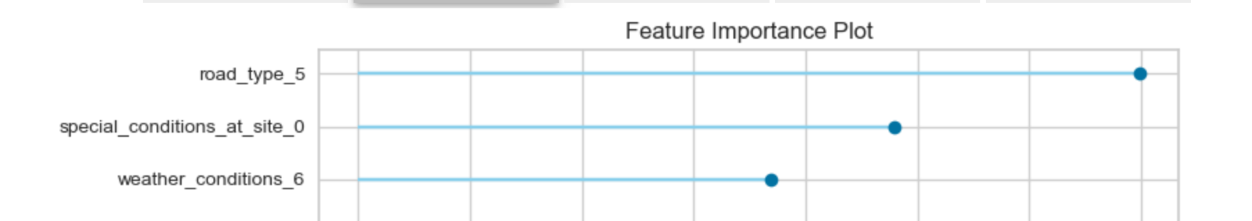  
 Feature Scores  
Fig Feature Importance Plot

We see that the road type and weather is considered to be in the top 3 of the Feature Importance as per our model. This is very interesting since our descriptive questions also ask this.

There is good evidence even with our predictive model that these features have an influence on number of casualties.

Now coming to our Predictive Question:

* Can we predict these incidents in advance to aid the public and the other interested parties?

Given our Linear Regression Model’s RMSE, the interesting features that are important for the model, we can most certainly make the predictions of casualties based on the road type and weather condition and special conditions on site we can create a forecasting model and warn the public accordingly of the casualties.

**Meaning of our RMSE:**

Our test and train accuracy are around 0.8. This means that the model can make an error of 0.8 at predicting values. The casualties range between the values of 1-10. Although our model makes an error of 0.8 we still have a good potential. Consider a casually number to be around 4. We may see a value of 3.2 or 4.8 from our model, but it still is a value addition since we know that there could be those many casualties and propre steps to avoid these casualties can be taken.

**Perspective Analysis Solution Proposed:**

To address our perspective question. From the descriptive analysis we have a few attributes which have influenced the casualties (weather and light conditions) and also the feature importance plot from our model we see that the following attributes at an accident site play major role at predicting casualties:

1. Weather Conditions (Rainy without high winds).
2. Lighting Conditions (Streelight present but unlit).
3. Road Type (roundabout ).
4. Special Condtions at site (accident site).

We see that based on above values the ministry of transportation can assign and designate areas that need to take high precaution and be ready for a casualty. The public can be alerted to the possibility of accident and also the police force can be set on stand by in the nearest areas.

Yes, there can be some hindrance in execution of our solution, that is alerts sent to public either may be too frequent during certain weather conditions/ during power outages. We also see that it might be expensive for the ministry to set police forces on high alert. But we have data supporting the severity of the situation (loss of life) and we believe that some additional budgets can spared in this direction. If needed the modifications to alerts and the force deployment can be done post the implementation of our solution and iteration by iteration the policies and solutions can be enhanced.

# 

# APPENDIX

|  |  |  |
| --- | --- | --- |
| **Columns** | **Data-Type** | **Brief Description** |
| Accident ID | Numeric | Unique ID |
| Police Force | Numeric (Ratio) | A numeric value for the police force present. |
| Number of Vehicles | Numeric (Ratio) | Number of vehicles involved in the accident. |
| Number_of_Casualties | Numeric (Ratio) | Number of casualties in the accident. |
| Date | Date Data Type | Date on which the accident took place. |
| Day_of_Week | Date Data Type | Day of the week on which the accident took place. |
| Time | Time | Time in the 24hr format when the accident took place. |
| Local_Authority_(District) | Numeric | Numeric value. |
| Local_Authority_(Highway) | Categorical (nominal) | The local governing body at the place where accident took place. |
| 1st_Road_Class | Categorical (nominal) | The roads owned by the state government. |
| 1st_Road_Number | Categorical (nominal) | The limited-access highways under the State Management. |
| Road Type | Categorical (nominal) | Type of the road where the accident occurred, like, public roads, drivable, non-drivable roads. |
| Speed limit | Numeric | Speed Limit on the road in mph. |
| 2nd_Road_Class | Categorical (nominal) | The roads owned by the regions itself and form the primary network for the urban areas. |
| 2nd_Road_Number | Categorical (nominal) | The main arteries in the entire country. |
| Pedestrian_Crossing-Human_Control | Categorical (nominal) | The roads which allow pedestrians, cyclists, and horse-riders to pass through a road, just by pressing a button. |
| Pedestrian_Crossing-Physical_Facilities | Categorical (nominal) | The roads which have the facilities through physical barriers like rivers, canals etc., for the pedestrians to pass through. |
| Light Conditions | Categorical (nominal) | Lighting conditions (accident happened in day/ night), was street light present |
| Weather Conditions | Categorical (nominal) | If the weather is god or bad, like, rainy, cloudy, windy, bright etc. |
| Road_Surface_Conditions | Categorical (nominal) | Surface condition of the road, if the road has any pothole, cracked pavements etc. |
| Special_Conditions_at_Site | Categorical (nominal) | Anything special happened on the road(like a lockdown) or another accident or a sudden intrusion. |
| Carriageway Hazards | Categorical (nominal) | Any hazards like oil leakage, containers slipping etc |
| Urban_or_Rural_Area | Categorical (nominal) | Urban (1) or Rural (0) |
| Did_Police_Officer_Attend_Scene_of_Accident | Boolean | Self-explanatory column |
| state | Categorical (nominal) | The state where the accident took place. |
| postcode | Categorical (nominal) | Zip code of the area where the accident took place. |
| country | Categorical (nominal) | Constant United Kingdom (This will be dropped as it is a constant.) |

**Column Names before:**

Accident_ID

Police_Force

Number_of_Vehicles

Number_of_Casualties

Date

Day_of_Week

Time

Local_Authority_(District)

Local_Authority_(Highway)

1st_Road_Class

1st_Road_Number

Road_Type

Speed_limit

2nd_Road_Class

2nd_Road_Number

Pedestrian_Crossing-Human_Control

Pedestrian_Crossing-Physical_Facilities

Light_Conditions

Weather_Conditions

Road_Surface_Conditions

Special_Conditions_at_Site

Carriageway_Hazards

Urban_or_Rural_Area

Did_Police_Officer_Attend_Scene_of_Accident

state

postcode

country

**Column Names After:**

accident_id

police_force

number_of_vehicles

number_of_casualties

date

day_of_week

time

local_authority_district_

local_authority_highway_

1st_road_class

1st_road_number

road_type

speed_limit

2nd_road_class

2nd_road_number

pedestrian_crossing_human_control

pedestrian_crossing_physical_facilities

light_conditions

weather_conditions

road_surface_conditions

special_conditions_at_site

carriageway_hazards

urban_or_rural_area

did_police_officer_attend_scene_of_accident

state

postcode

country

Creating the accident risk index:

# we need to calculate Accident_Risk_Index as sum(Number_of_casualities)/count(Accident_ID)

grouped_train = train.groupby('postcode') # group by postcode

#create aggregation functions

aggregations = {'Number_of_Casualties': [np.mean],

'Accident_ID': [np.count_nonzero]}

aggregated_ = grouped_train.agg(aggregations)

# formula mentioned above is used to calculate <Accident_Risk_Index>

aggregated_['Accident_Risk_Index'] = aggregated_['Number_of_Casualties']['mean']/aggregated_['Accident_ID']['count_nonzero']

Result:

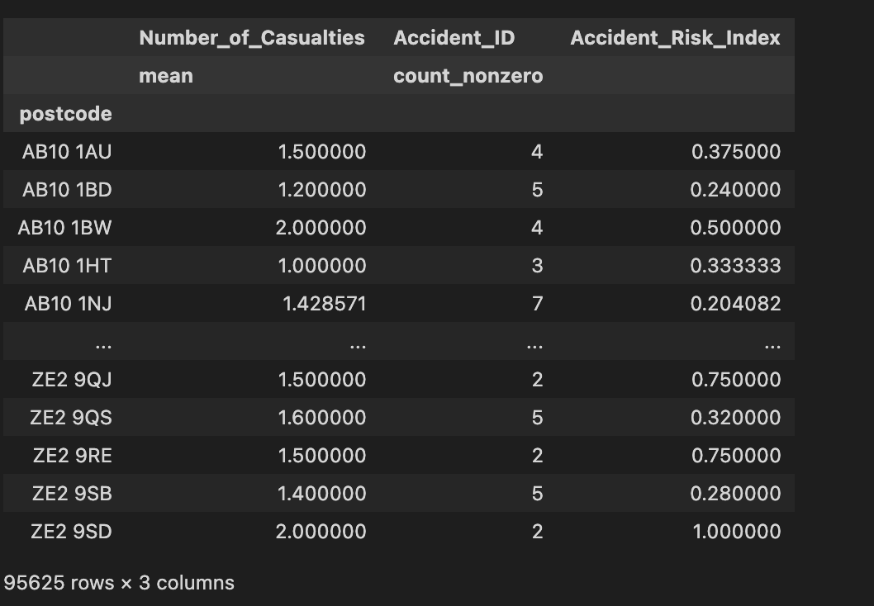

​​

Pycaret.regression.setup

(data: Union[pandas.core.frame.DataFrame, Callable[[], pandas.core.frame.DataFrame]], target: str, train_size: float = 0.7, test_data: Optional[pandas.core.frame.DataFrame] = None, preprocess: bool = True, imputation_type: str = 'simple', iterative_imputation_iters: int = 5, categorical_features: Optional[List[str]] = None, categorical_imputation: str = 'constant', categorical_iterative_imputer: Union[str, Any] = 'lightgbm', ordinal_features: Optional[Dict[str, list]] = None, high_cardinality_features: Optional[List[str]] = None, high_cardinality_method: str = 'frequency', numeric_features: Optional[List[str]] = None, numeric_imputation: str = 'mean', numeric_iterative_imputer: Union[str, Any] = 'lightgbm', date_features: Optional[List[str]] = None, ignore_features: Optional[List[str]] = None, normalize: bool = False, normalize_method: str = 'zscore', transformation: bool = False, transformation_method: str = 'yeo-johnson', handle_unknown_categorical: bool = True, unknown_categorical_method: str = 'least_frequent', pca: bool = False, pca_method: str = 'linear', pca_components: Optional[float] = None, ignore_low_variance: bool = False, combine_rare_levels: bool = False, rare_level_threshold: float = 0.1, bin_numeric_features: Optional[List[str]] = None, remove_outliers: bool = False, outliers_threshold: float = 0.05, remove_multicollinearity: bool = False, multicollinearity_threshold: float = 0.9, remove_perfect_collinearity: bool = True, create_clusters: bool = False, cluster_iter: int = 20, polynomial_features: bool = False, polynomial_degree: int = 2, trigonometry_features: bool = False, polynomial_threshold: float = 0.1, group_features: Optional[List[str]] = None, group_names: Optional[List[str]] = None, feature_selection: bool = False, feature_selection_threshold: float = 0.8, feature_selection_method: str = 'classic', feature_interaction: bool = False, feature_ratio: bool = False, interaction_threshold: float = 0.01, transform_target: bool = False, transform_target_method: str = 'box-cox', data_split_shuffle: bool = True, data_split_stratify: Union[bool, List[str]] = False, fold_strategy: Union[str, Any] = 'kfold', fold: int = 10, fold_shuffle: bool = False, fold_groups: Optional[Union[str, pandas.core.frame.DataFrame]] = None, n_jobs: Optional[int] = - 1, use_gpu: bool = False, custom_pipeline: Optional[Union[Any, Tuple[str, Any], List[Any], List[Tuple[str, Any]]]] = None, html: bool = True, session_id: Optional[int] = None, log_experiment: Union[bool, str, pycaret.loggers.base_logger.BaseLogger, List[Union[str, pycaret.loggers.base_logger.BaseLogger]]] = False, experiment_name: Optional[str] = None, experiment_custom_tags: Optional[Dict[str, Any]] = None, log_plots: Union[bool, list] = False, log_profile: bool = False, log_data: bool = False, silent: bool = False, verbose: bool = True, profile: bool = False, profile_kwargs: Optional[Dict[str, Any]] = None

**Presentation slides:**

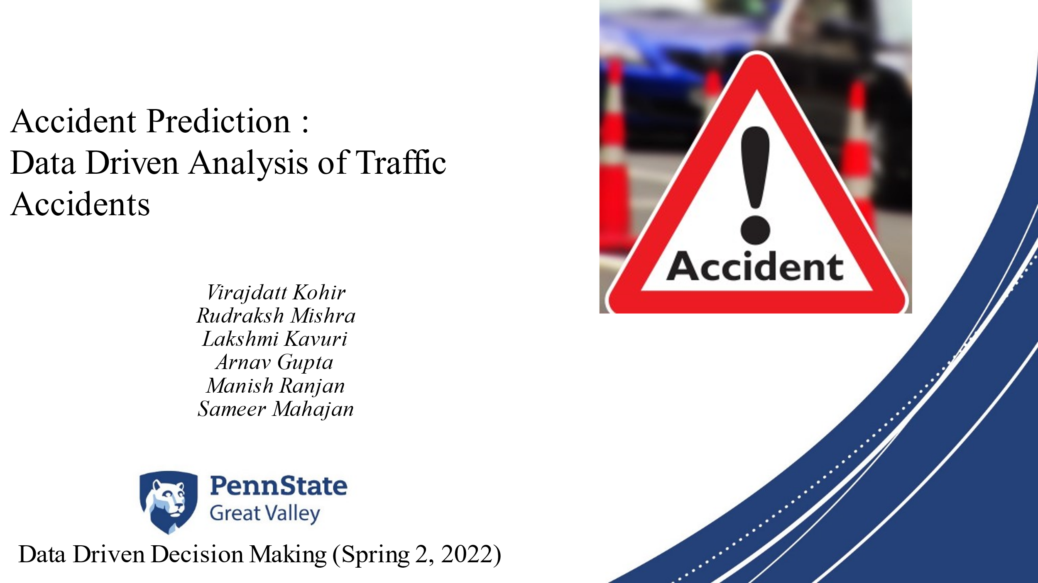



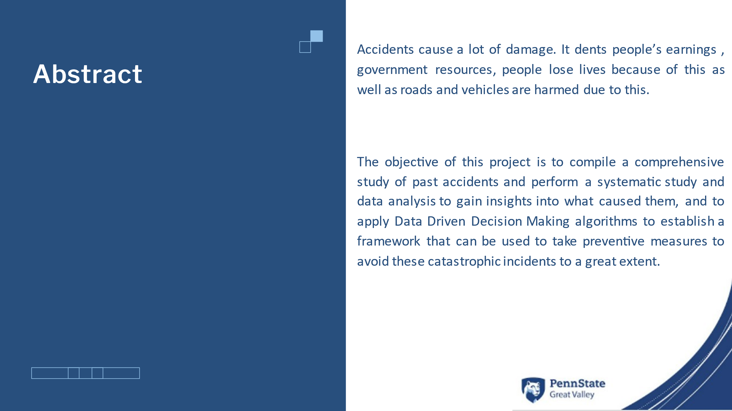

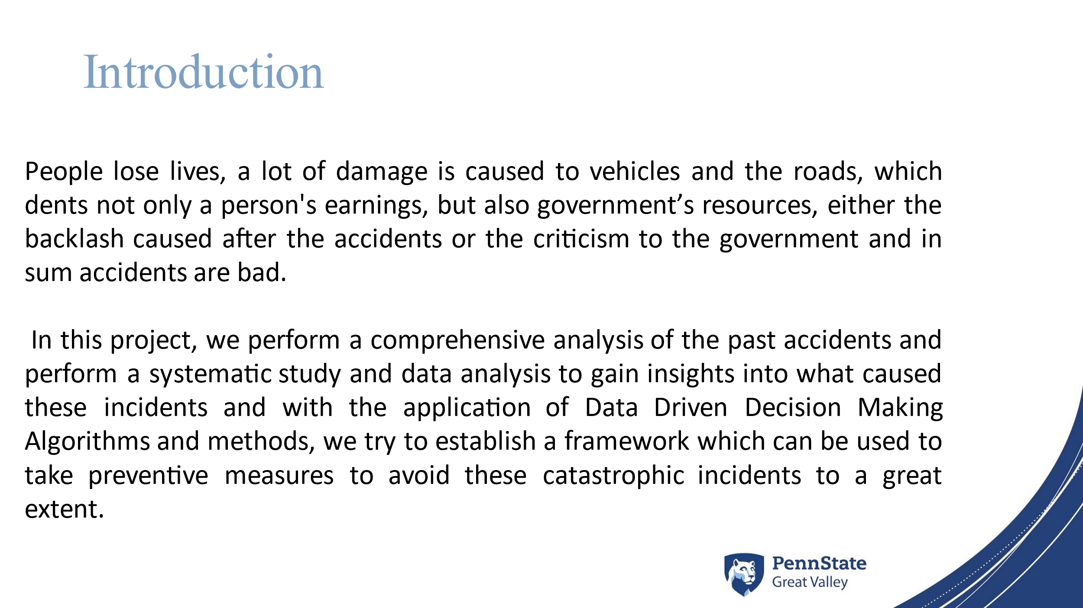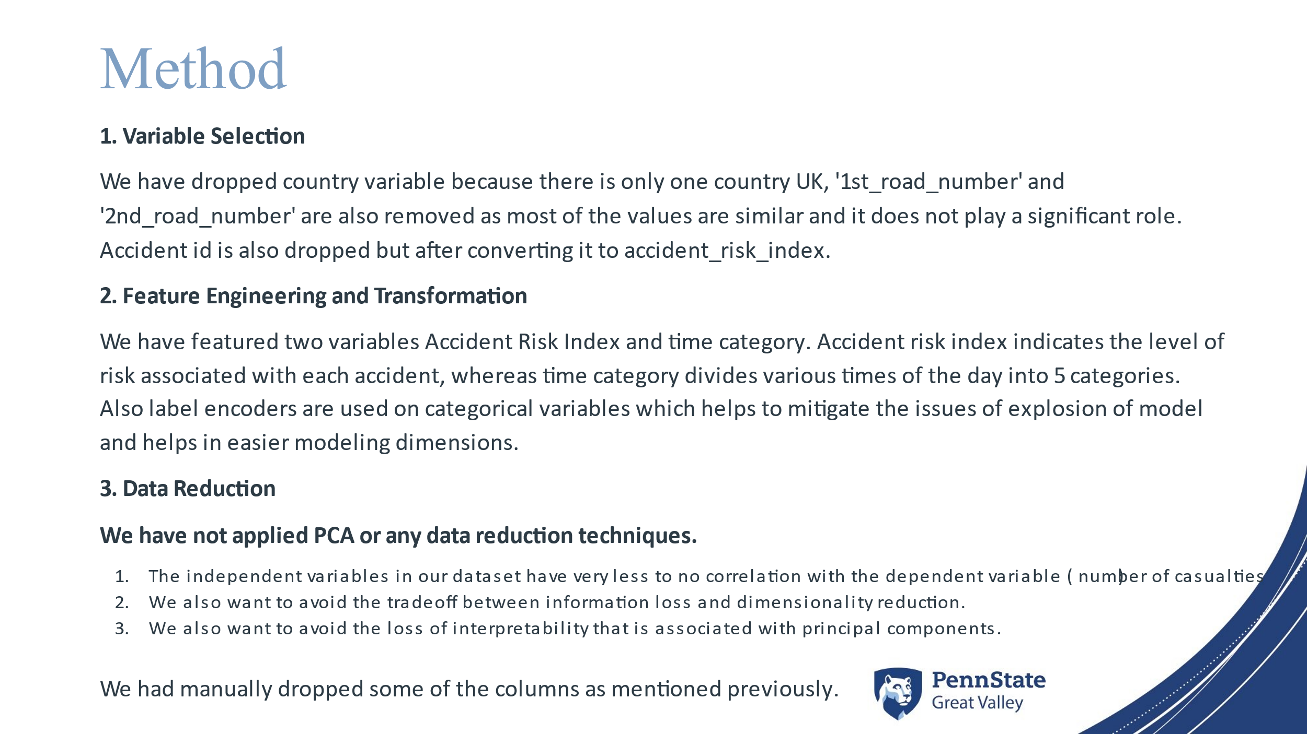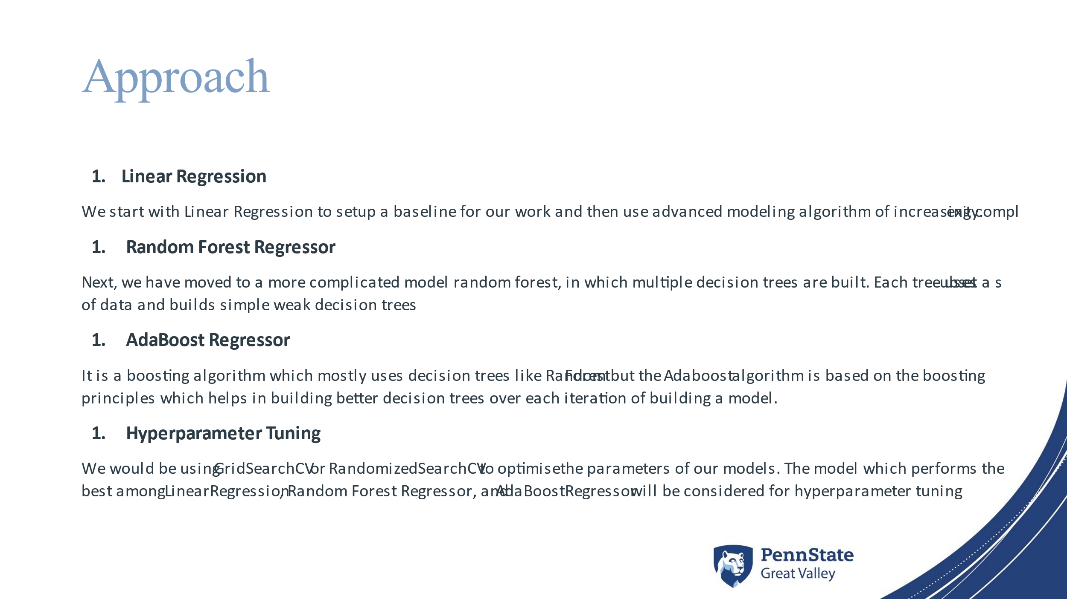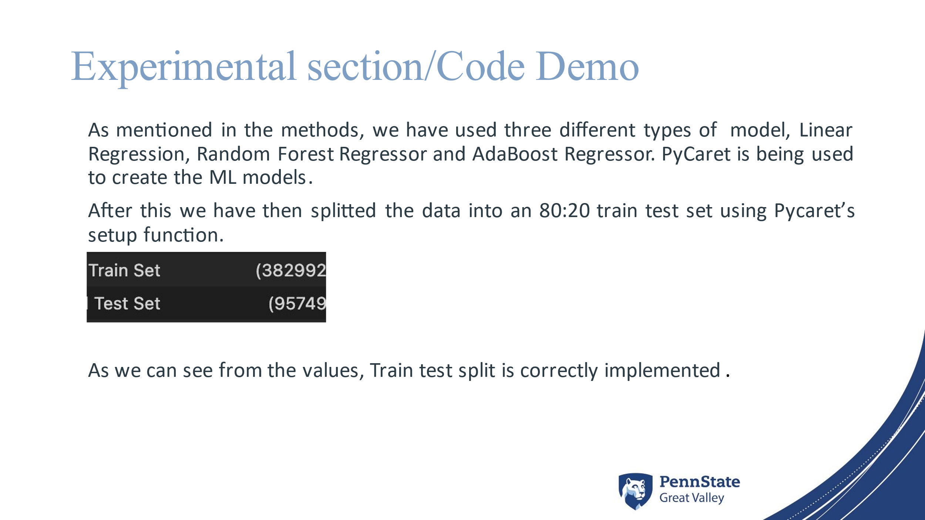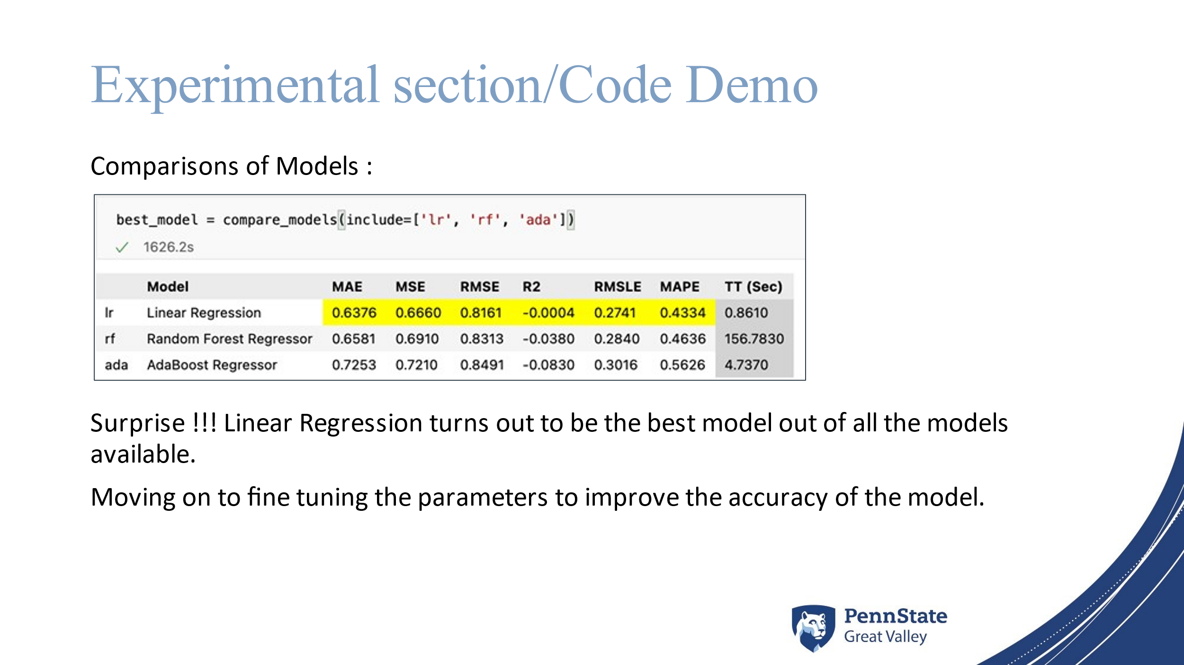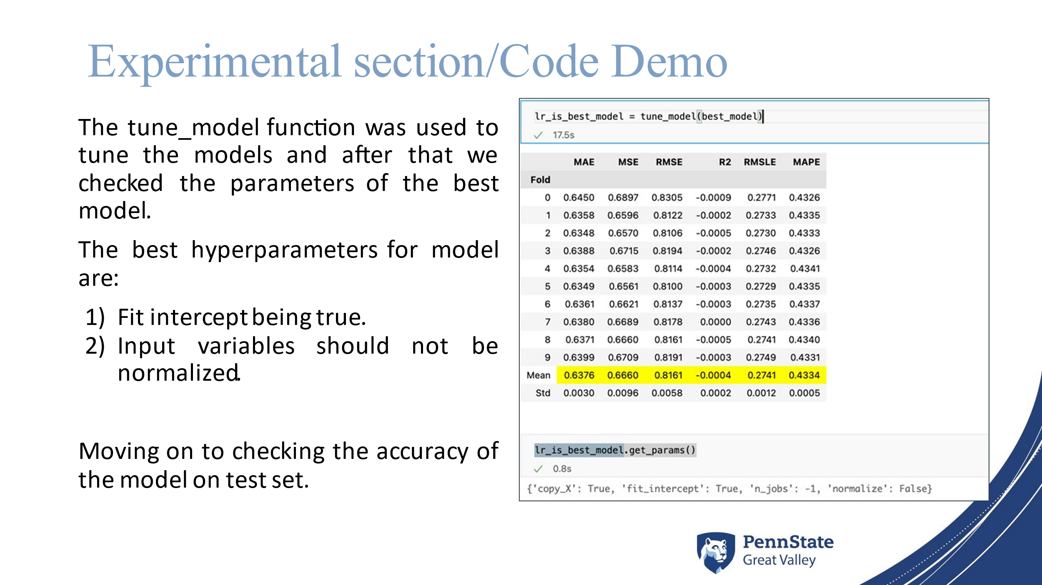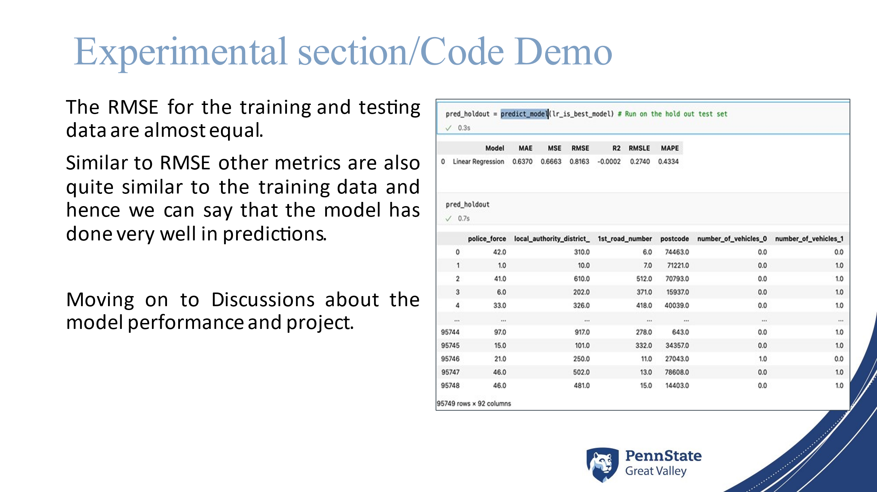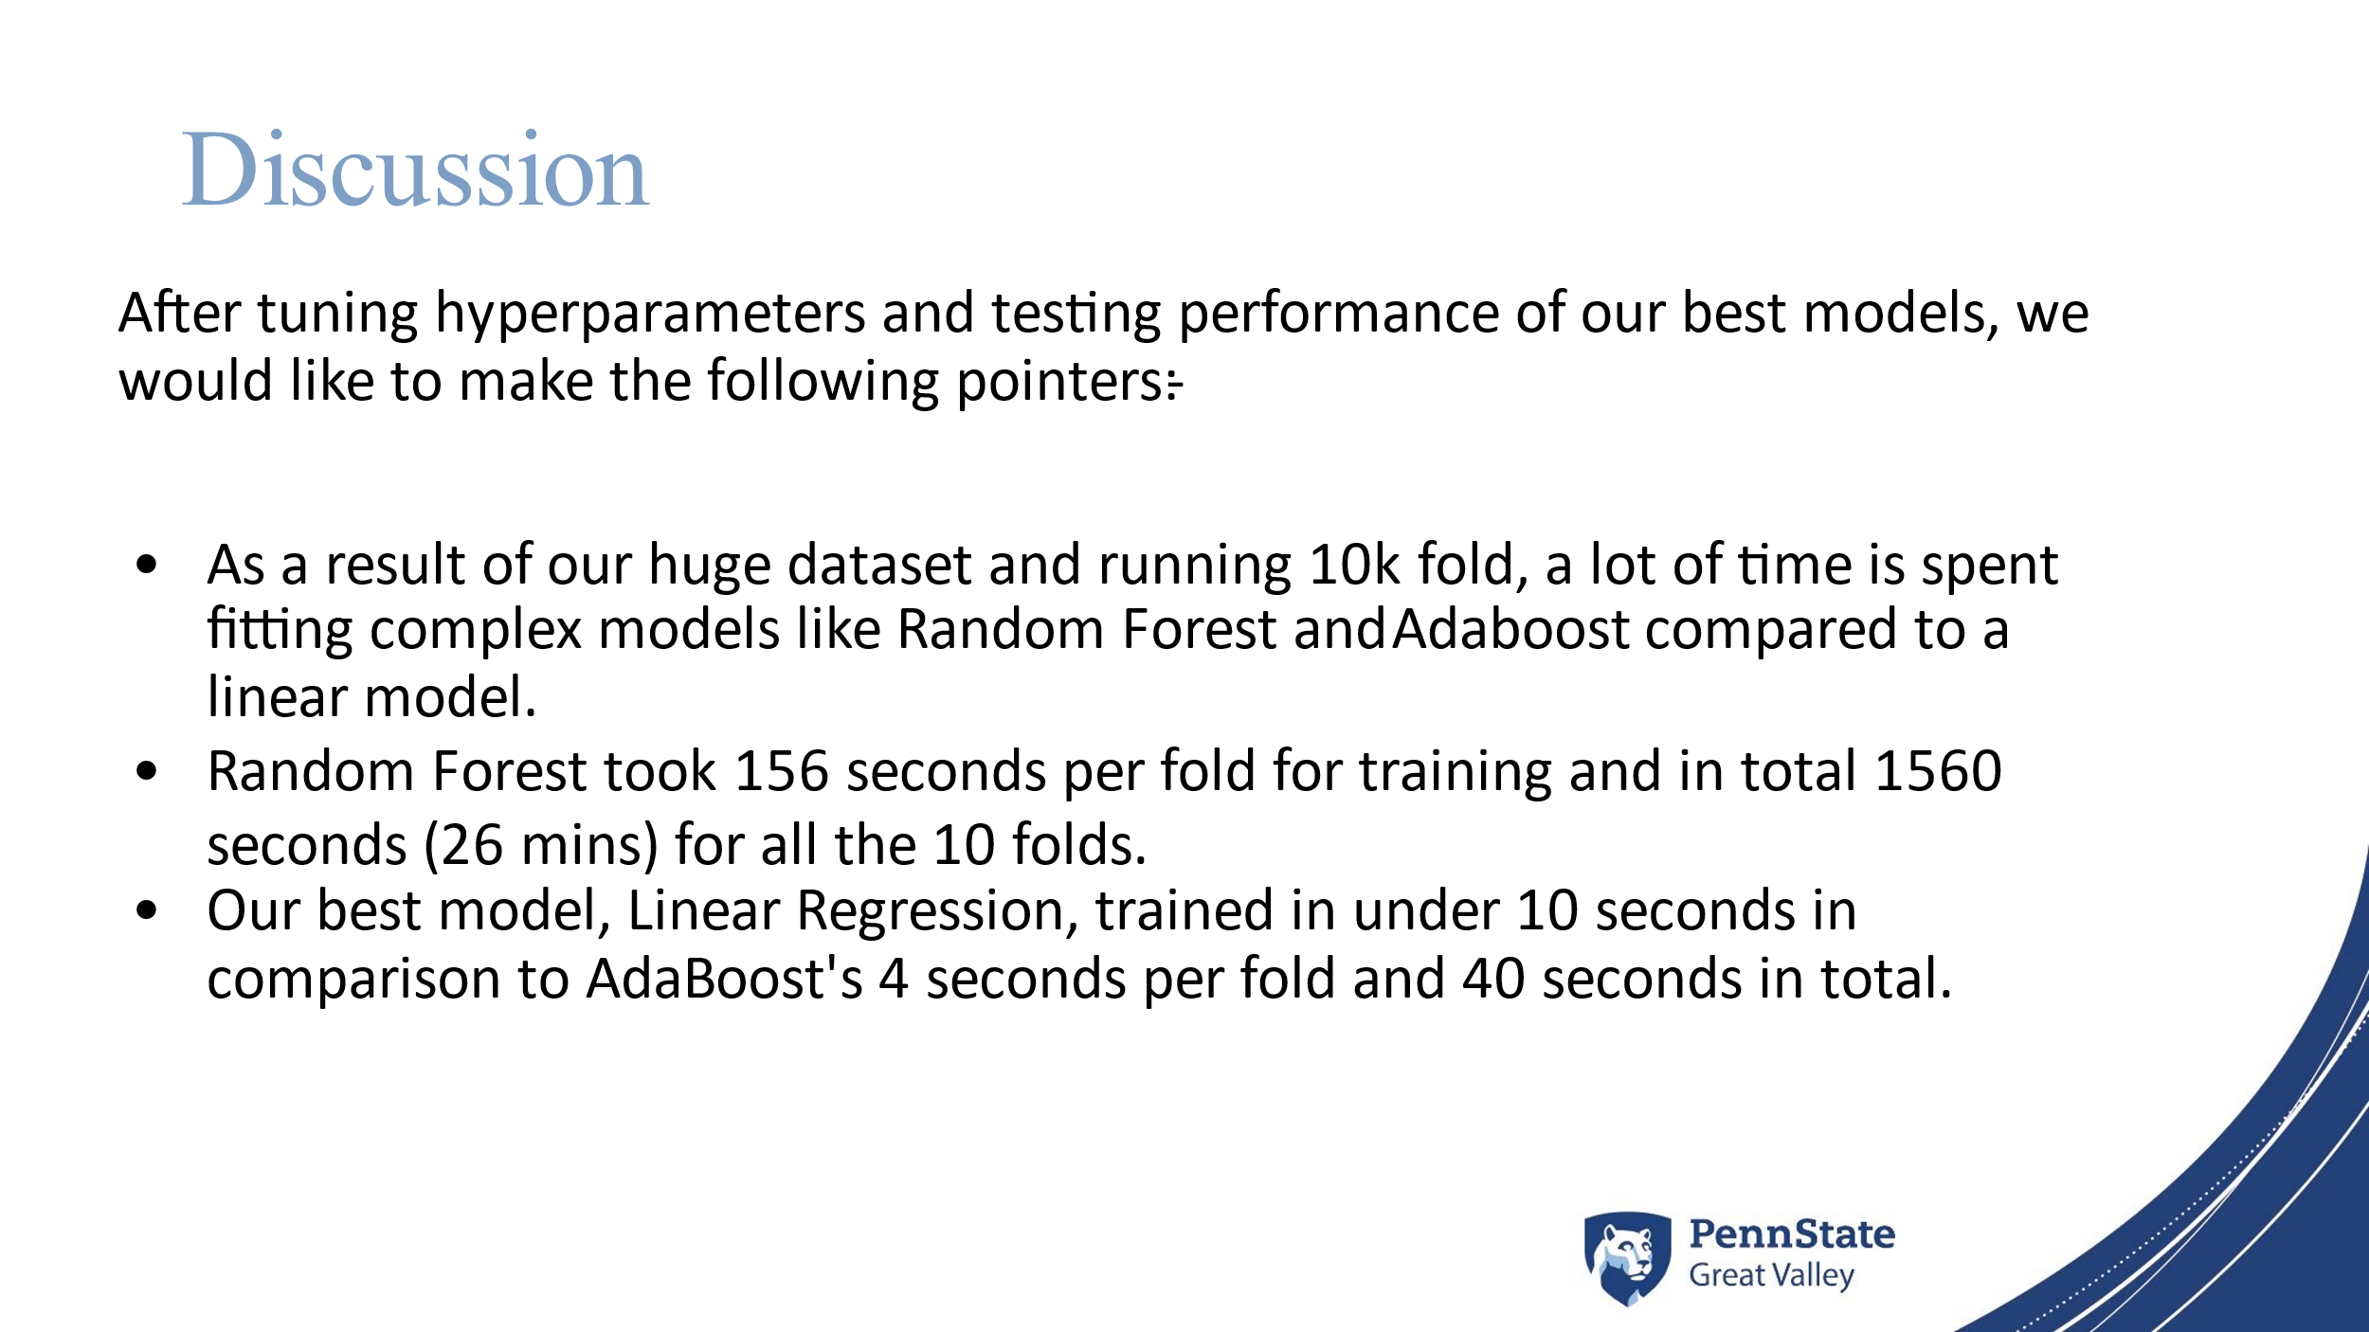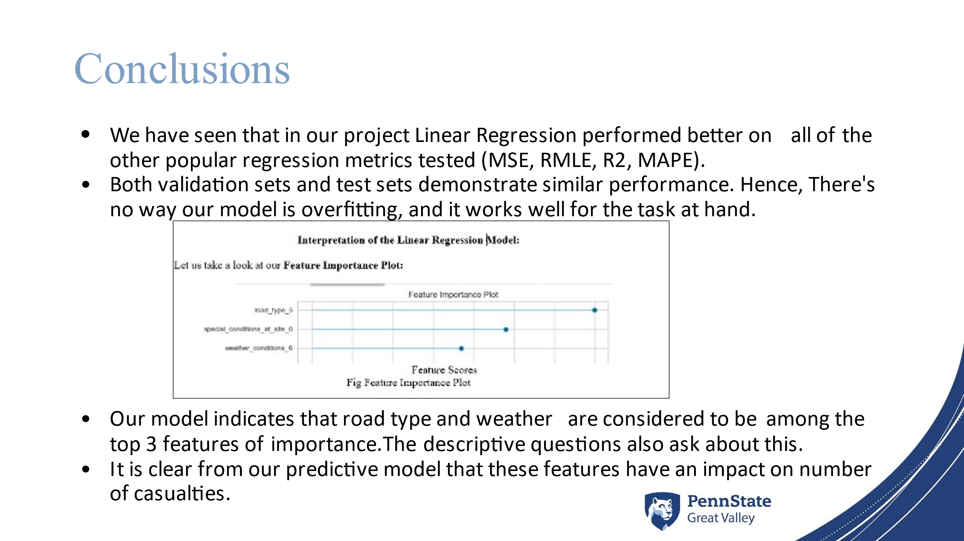

Recommendations from Peer/Instructor that were addressed:

* Time taken for Linear regression model was compared with other models and addressed properly
* Write how our predictions are good and what impact they create in the society. We give a definite range of how many accidents can happen with a low error (RMSE +- of 0.8), without these predictions one cannot know how many accidents will happen in a day (it can either be zero or go all the way till 10)
* Rewrote our pitch to have a better story to sell our project to investors.
* how our prediction models could be used to reduce road accidents.
* To show the clear report of this project
* Finished framing the prescriptive solution
* Added informative graphs in presentation as well
* Reason for using label encoders
* Included the detailed data description in report.

Work that will be experimented, researched and addressed in the future with more time in hand:

* Use the model to predict times of the day or year when a heavier police presence is necessary on highways
* The locations that police should crack down on
* Roadways that maybe engineers should look at redesigning to reduce accidents.
* Can try implementing deep learning models
* Experimenting with XGboost for modelling
* To implement multiclass logistic regression by converting the casualties into low medium high severity

## Resume/Cover Letter

* 1. Virajdatt Resume:



* Virajdatt Cover Letter:

To whomsoever it may concern,

I am a self certified geek with a growth-mindset and passion for all things computing, analytics, building data pipelines, deep learning and 4 years of professional experience, looking to further his research career with this position. I am confident that my experiences with building pipelines, dashboards, predictive modelling and deploying Machine and Deep Learning models will assist me in excelling at this position.

During the last 4 years with iManage in multiple positions, I have gained vast experience and skills with Azure Cloud, Python (test-driven development, pandas, sklearn, TensorFlow, keras etc..), GitHub, GitLab, Docker, Elastic-Search, Kubernetes, Zabbix etc. I am an avid learner, who loves to explore and implement new technologies and workflows. This passion of mine bagged me the global excellence award at iManage in 2019. I implemented an innovative pipeline with multiple tech stacks which reduced the manual work from 5 hours to 10 mins. Our CEO described the excellence award as “Displays creativity and innovation in devising processes and solving business problems that highly impact the organization.”

At iManage, I have developed and maintained a custom python package that builds dashboards (visualized through Zabbix and Grafana) and indicates statistics that help in fine tuning production system alerts. This package was used to reduce outages and increase the uptime from 99.1% to 99.99% across all the 7 data centers. This project helped me hone my advanced python, data pipeline,visualisation and docker skills and I also got accustomed to test-driven development.

I also am an edge ML and Raspberry-pi enthusiast. I have been using these devices for home automation and other side projects over the last 1.5 years.

I am confident that my passion, prior work experience, ability to learn quickly and my commitment to contributing and creating value will aid me in excelling at this position. I am looking forward to contributing in any way in areas like building data pipelines, dashboards, training Machine Learning and Deep Learning models. I aspire to be a full stack Deep Learning Engineer.

Thank you very much for your time and consideration.

Sincerely,

Virajdatt Vishaldatt Kohir

* Virajdatt Introduction:

Hello everyone, it is Virajdatt here. Before I introduce my project, I want to talk a little about myself and share with you part of my work. Currently I am a grad student at PSGV, working as a research assistant in the field of Cybersecurity in Natural Language Processing and Federated Learning.

Years ago, when I was in college and when Corona was just an expensive beer for me. I was a student pursuing Under Grad in UG and as like most of my peers, I too was driven by passion to make an impact through my computer skills. So, I formed a team of 4 members and pitched an idea for how we can reduce the power consumed in Wireless sensor networks. We 4 were very underprepared as we got to know when the pitch was over, and we received criticism and most daunting remarks about the infeasibility of the proposed idea and incoherence in delivering the project proposal. It was a great setback for me and the team.

It is through retrospection where we realize the flaws in our methods. We had not practiced pitch, which was removed of all jargons, we didn’t have enough visuals in our slides, we didn’t talk enough about the potential applications. After months of grinding, skilling up technically and as well as a salesman we went and pitched the idea to the State Government of Karnataka for funding. All the retrospection and hard work seemed to come in handy when our proposal was accepted (it also was one among the 4 approved CS projects out of 500+ proposals ). The success of our work echoed back to us when the project also won the INNOVATA-2k17 National Level tech fest.

I know it was enough bragging, but the point I am making is there is great value in failure when the mistakes are analyzed, studied and milked appropriately. Looking back, analyzing the past and then making better decisions improves you and your future for sure.

With all this I now bring to you along with my team this project on improving the life conditions of drivers, insurance companies and government through analysis of past accidents. In this project we aim at understanding what causes the accidents, how can we prevent them, and can we predict them? Hop on the ride as we take you through the journey of what has been done and what can be improved for a better future.

* 1. Rudraksh Mishra Resume:



* Rudraksh Cover Letter:

Dear XYZ,

With the utmost enthusiasm, I would like to express my interest in the data science intern position. As an analytical and results-driven professional, I believe my versatile skills and qualifications will make me a great asset to the team.

I have had a variety of experiences with many different roles, including data science internships at Toyota and Wipro Technologies. I enjoy building end-to-end machine learning & statistical solutions to solve complex, real-world business problems. I have extensive experience in Python, R, SQL, Tableau, PowerBI, and Excel. I am dedicated to continuously learning and enhancing my skills.

Some notable achievements of my last year’s work include:

• At Toyota, I developed a computer vision system to evaluate 160 employees’ performance based on the mishandling of product assemblies. Analyzed collected data to discover patterns in faults. After multiple weeks of testing, receiving feedback, and iterating, I improved assembly line work efficiency by 14%.

• Predicted customers' churn ratio on IBM telecommunication dataset. This was based on their usage history and a result of performance comparison of 11 classifiers. Analyzing these predictions and clusters, one could conclude which will be the best course of action to retain maximum customers.

• Designed a database system for a restaurant management system, built reports and preprocessed data (data cleaning &wrangling) on multiple conditions by using Oracle SQL and Excel.

• Analyzed the pattern among different types of crimes, relationships across multiple regions on FBI's Supplementary Homicide Report using Tableau to increase the crime-solving rate.

I admire xyz Company’s dedication to data-informed product building, and I am confident I can be an asset to the team while gaining a valuable learning experience. While my resume provides a history of my past experiences, there is considerably more to share. I hope to arrange a time to meet so that I can learn more about what your company needs and how I can help bring great success to us both.

Sincerely,

Rudy Mishra

* Rudraksh Introduction:

Hello everyone, I am Rudraksh Mishra, you can all me Rudy. I am a full-time student at PSUGV, pursuing MPS DAAN and working as a machine learning research assistant. I am an enthusiastic data scientist with expertise in Python. I have interned at three different companies in past (Toyota, Wipro Technologies and GND solutions) as a data scientist and data analyst. I have completed my bachelors in Electronics and Communication with a minor in CS from Christ University, Bangalore India. I am from Bangalore India (it is the IT hub of India and is known for its pleasant weather). During my latest data science internship at Toyota, I built a computer vision system that analyzed and evaluated 160 employees’ performance to attain data for mishandling of product assemblies and predicted peak faults using machine learning algorithms, which improved the work efficiency by 14% and resulted in estimated annual savings of $85K.

My short-term goal is to complete and deploy my ongoing end to end project ideas and also to learn how to make data driven decisions on real-world financial business problems from my upcoming internship in finance domain as a data scientist intern. In long term, I inspire to work as a machine learning specialist, using statistical approaches to solve business solution.

From data driven decision making course I wish to have a clear understanding about the facts, measurements, and statistics that are used to influence strategic business decisions that are in line with the project’s goals/ objectives. Many businesses are establishing three essential characteristics in order to become data-driven: data competence, analytics agility, and community. It's not easy to change the way your firm makes decisions but putting data and analytics into decision-making cycles is where you'll see the most significant changes. Therefore, from this course I would love to explore different ways data is used to make business decisions.

* 1. Lakshmi Kavuri Resume:

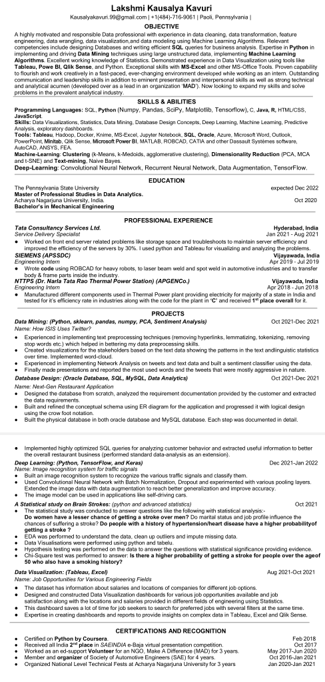

* Lakshmi Cover Letter:

Dear Professor,

I would introduce myself as a very analytical, innovative, and superintended extrovert who is

very confident in her ability to perform tasks as a Data Analyst. In the tenure of 7 months in my job as a Junior Developer, I have good understanding in Snowflake, Microsoft Power BI and Qlik Sense. I also have expertise in MS-Excel, MATLAB, Azure cloud. During the last couple of months, I spent an extensive time learning Python, SQL, Tableau, Neural Networks. I have hands-on experience with software like Hadoop, Docker, Minitab, MS- Office.

My potential for being an excellent Data Analyst comes from my strong foundation in

Mathematics, particularly Statistics (Minitab, Excel, Python), Data Visualizations and creating exploratory dashboards for the project. I am also knowledgeable about Databases and Data Mining with a couple of projects in hand. I am very well versed in data cleaning, data wrangling, data transformation using feature engineering, data modelling.

My extra merits include being very familiar with JavaScript, CSS , C & Java programming

languages. I have magnificent communication skills and exceptional ability to work creatively in a fast-paced environment. I am also self-assured about my leadership skills being a lead of team with 25 members for 2 years and my positivity also comes from teaching 8th and 9th graders in an NGO called ‘Make A Difference’. I am confident that I will definitely be helpful to the organization, and I believe my hunger and passion for learning will make me a great asset for your esteemed organization.

* Lakshmi Introduction:

I am Lakshmi Kausalya Kavuri pursuing my Master's in Data Analytics with a passion to learn and understand data better so as to have better perception and give better results through the data. I have a good understanding of data tools like Tableau, Minitab, MATLAB, Hadoop, Docker and am knowledgeable in Python, SQL, HTML, JavaScript, C etc. but I wish to improve and hone my skills further to be a better data analyst who can provide better insights to the data.

I have hands-on experience with couple of projects now and my role as assistant developer in TCS taught me the usage of tools like Snowflake, Qlik and Power BI. I personally want to know and have good understanding of the data to give thorough outputs and utilize time by only looking at the data that's needed to take decisions.

1. Arnav Gupta Resume:

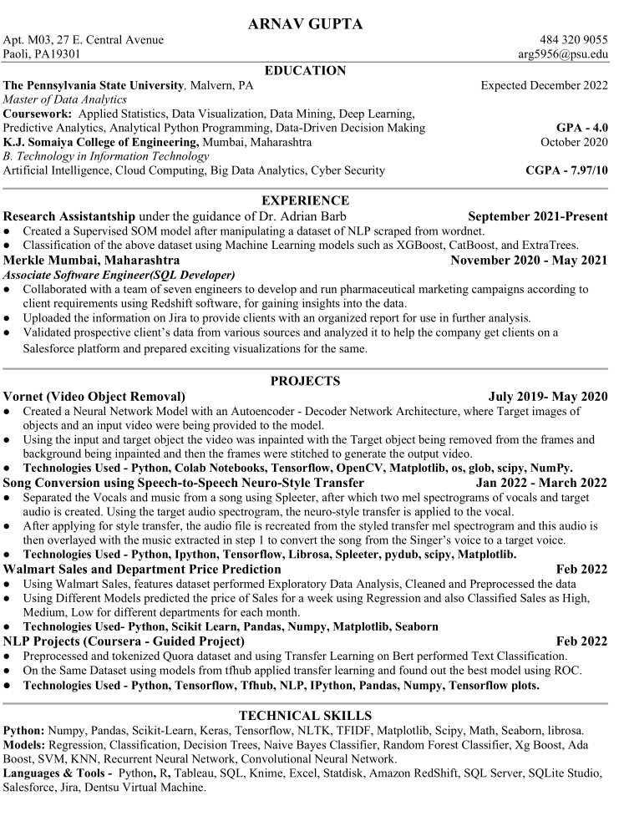

* Arnav Cover Letter:

Dear Hiring Manager:

Thank you for the opportunity to apply for the Data Analyst Intern position. I have an undergraduate degree in Information Technology from the University of Mumbai and have a year’s work experience as an Associate Software Engineer (SQL developer) in Merkle Mumbai. I’m currently pursuing a master’s degree in Data Analytics from Pennsylvania state university.

I have worked on Several Projects in the past, one of which is Video Object Removal, where a target object is specified or input frames of the target object are given to the model, as well as an input video containing the target object is also given to the model. The output generated by the model will be a video with the target object being removed from the video and the background being imprinted such that it looks as if the object was not present in the video.

Another one of my Projects included working on Tableau with a NY accident dataset. First Data Exploration of the dataset was being done with different statistics to gain interesting insights on the data. Then the data was cleaned and preprocessed, and after this using Tableau, I had created captivating visualizations using this dataset.

During my time as a Software engineer, I was working on a Project AbbVie where we were running pharmaceutical campaigns using SQL according to the needs of the client on Redshift software, for gaining insights into the data. After running these campaigns, the results were uploaded on Jira to provide our clients with further analysis on these data.

I was also responsible for Validating Potential Clients for the company by analyzing their data from various sources and helping the company in getting their next Client and preparing exciting visualizations and report analyses for the same all on the Salesforce platform. All of these tasks were new for me, but I demonstrated perseverance, hard work, Quick but efficient learning skills in this job, and also willingness to learn new technologies and tools.

At present, I'm working part-time on a project, Song Conversion using Speech-to-Speech Neuro-Style Transfer where I am isolating the music and vocals from a song, then converting the vocals of the song to Mel spectrogram, and then using Convolution Neural Networks applying Style transfer of this spectrogram to a target spectrogram and then again converting back this spectrogram to the audio sample.

I am confident I would be an immediate asset to your team while gaining a valuable learning experience. I would like an opportunity to meet with you to further discuss my skills and experience related to the position. I can be reached at 484-320-9055, <arg5956@psu.edu>.

I appreciate your time and consideration.

Sincerely,

Arnav Gupta.

* Arnav Introduction:

Hello Everyone,

I am a full-time student enrolled in MS DAAN.

My name is Arnav Gupta and I am a full-time student at PSU GV, pursuing MS in Data Analytics.

I am from Mumbai; India and I have completed my Bachelors in Information Technology from the University of Mumbai. Mumbai is very famous for its local trains and its nightlife.

I have worked as an Associate SQL developer at Merkle Mumbai after I had completed my graduation.

Data is everywhere and in various forms and it is very important to understand what the data wants to say instead of making what you want to say from the data. To interpret data effectively while making decisions is a skill that everyone pursuing data scientist/analysis should be able to learn and understand and that is exactly what expectations I have from this course to learn.

I am a practical based person, an introvert, technologically driven, and lie somewhere at the point of the middle in making decisions based on Data and emotions as data can also hide important information not seen to the naked eye and based on the business goal it is important how to interpret the data-driven decisions and emotion-driven decisions or as said in a layman language going with your gut.

Thank you.

1. Manish Ranjan Resume:

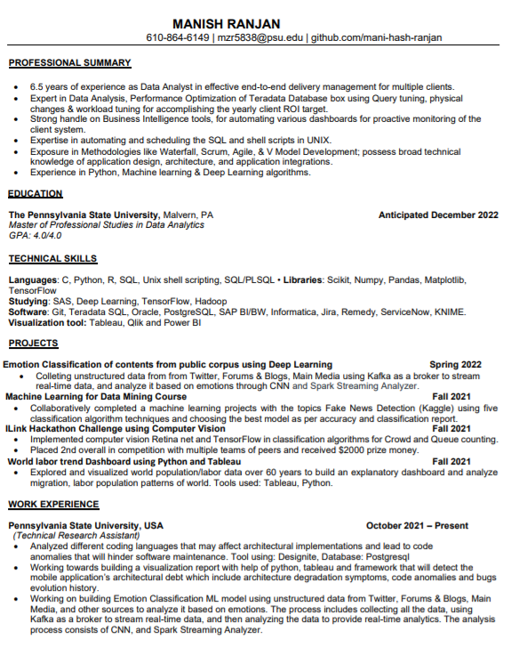

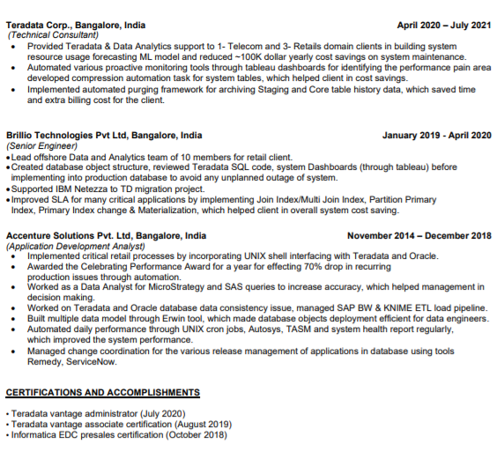

* Manish Cover Letter:

Dear Hiring Manager:

Thank you for the opportunity to apply for Data Analyst position. I have an undergraduate degree in Computer Technology, along with 6.5 years of work experience as a data analyst, SQL developer, Production Support, and Database Administrator. I’m currently pursuing master’s degree in Data Analytics from Pennsylvania state university.

During my time as a Database Analyst at Teradata Corp. I was maintaining end to end data delivery management for our client by using machine learning and data visualization tools. I was also maintaining dashboards for multiple reports as per client requirements and consistently received positive feedback about my performance.

I have extensive knowledge working directly with multiple clients for their data warehouse system maintenance. I have moderate experience working on big data technologies (such as Hadoop) for generating reports for bad performing queries from Teradata database. Throughout my career I have demonstrated my ability to achieve beyond expectations. I am a quick learner and eager to take on new technologies and tasks.

At present, I'm working part-time on two research projects, one involves analyzing multiple anomalies in application code and building visualization using Python and Tableau. Another project involves emotional classification of public content using Deep Learning using unstructured data from Twitter, Forums & Blogs, Main Media, and other sources to analyze it based on emotions.

I am confident I would be an immediate asset to your team while gaining a valuable learning experience. I would like an opportunity to meet with you to further discuss my skills and experience related to the position. I can be reached at 610-864-6149, <Mzr5838@psu.edu>.

I appreciate your time and consideration.

Sincerely,

Manish Ranjan

* Manish Introduction:

My name is Manish Ranjan, pursuing master’s in data analytics at Penn state great valley.

I have identified that there is a huge influx of data that is yet to be explored effectively.

Having basic knowledge of Applied Statistics and Mathematics, I’ve realized that everything can be related to something and that something defines something else, which can explain a lot of things and I am good at that. My insatiable curiosity about identifying patterns and finding insights out of large amounts of messy data makes me want to get out of bed every day. With my Master's in Data Science, my goal would be to keep learning every day and apply my knowledge and skills to solve big data problems and make an impact on the lives of people.

Every year, thousands of serious injuries are caused by road accidents. Often, local law enforcement officials are unable to pinpoint the exact conditions that lead to such events, therefore unable to address the number and severity of road accidents.

I want to propose to a research project that could help in analyzing and preventing the road accidents and answering various research questions. Such as, what are the regions or areas with most frequent accidents? What kind of street or highways are more likely to have accidents? etc.

Eventually, we will figure out a way to apply machine learning to this dataset to see if we can get any useful results. We will be focusing on different road and weather conditions, such as, Daylight, Streetlight, Rainy and snowy weather etc. Different machine learning algorithms will be used to predict the severity of accidents. Our team of five will work on this project and see if we can predict the factors that cause road accidents. To better foster road safety, we would like to identify high-priority areas for government funding.

As a result of this Data Driven Analysis, we will be gaining deeper insights into the underlying causes of accidents, empowering drivers, and governments alike to prevent them before they occur.

If you would like to know more about this project, we can arrange a time when it's convenient for you to meet.

1. Sameer Mahajan’s Resume:

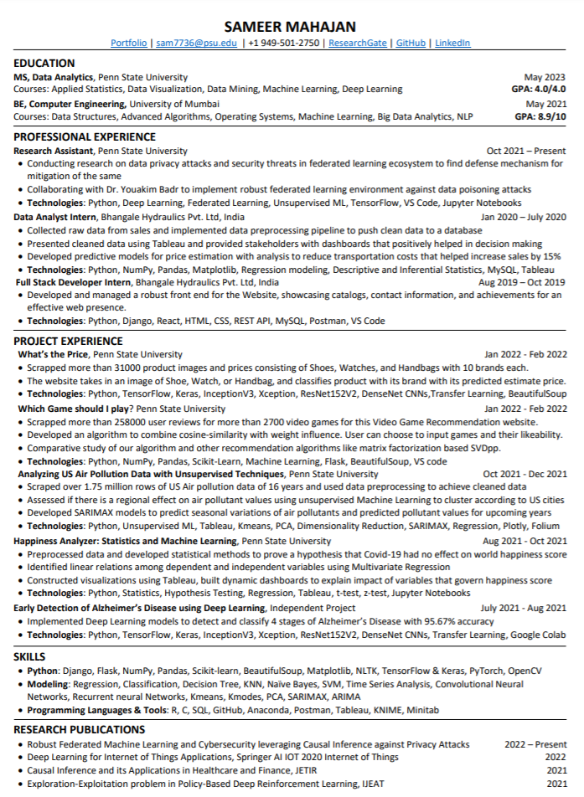

* Sameer’s Cover letter:

I was delighted to see your job listing for a Data Analyst Internship position at General Motors Financial. As a Masters in Data Analytics student from Penn State University, I have been working on various projects and research related to the field of Data Science and Analytics. My coursework in Data Analytics, enriched by extracurricular experiences such as projects, research, and online courses are preparing me for success, and I am excited to put my skills to use to solve real-world problems at General Motors Financial.

Everyone in the field of Data Science talks about that “Ahaa moment”, my experiences at the Data Analyst Internship at Bhangale Hydraulics Pvt. Ltd. were just that. Here I worked with raw data, preprocessed it, and used it to find solutions that saved the company a lot of money by better transport solutions and sales strategy. I found out my interests in data and I understood that with data one can solve many problems or optimize current solutions. From then, I was always fascinated by the Data Science world, and I am taking courses like Deep Learning, Machine Learning, Analytics in Python, and Marketing Analytics in Spring 2022 to gain insightful knowledge in the world of Data Science. Meanwhile, I have been working on various Machine Learning, Statistics, and Deep Learning projects to enhance my Data Science knowledge. The Applied Statistics project on World happiness gave me various statistical and Machine Learning skills used to test hypotheses and to use statistics to find answers to various questions. I am equipped with Data Visualization skills using Tableau and Python which helped me get insightful information from the various datasets I have worked on. I am putting Data Cleaning and Preprocessing skills in use for cleaning millions of data rows in my Data Mining project on US Air Pollution in which I am scrapping data from 2000 to 2016 for various cities across the US.

On the research side, I am working on Early Detection of Alzheimer’s Disease using Deep Learning techniques such as custom InceptionV3, Xception, ResNet152V2, DenseNet CNN models to classify MRI scans in 4 classes. I also aim to explore how Causal Inference can aid in personalized treatments for Alzheimer's patients in their early stages. One of my research chapters titled, “Architecture, Generative Model, and Deep Reinforcement Learning for IoT Applications: Deep Learning Perspective” was recently published by Springer publications. This chapter is a part of the book titled, "Artificial intelligence-based Internet of Things Systems". The chapter covers Deep Learning Architecture, Generative Models, Deep Reinforcement Learning, and its applications in IoT. Covid-19 is considered through the Deep Learning lens. Various applications for Deep Learning in IoT, Challenges in Deep Learning for IoT, and Research Gaps have been briefly discussed in this compiled chapter. Moreover, I am also working on distributed Machine Learning and Cybersecurity with the aim of providing a framework that not only protects the user’s privacy and security but also makes the Federated Learning environment more robust against various Cybersecurity attacks. This research has many applications in the world mainly because privacy and security is one of the topmost priorities for companies like General Motors Financial. This research could help leverage the benefits of Machine Learning by maintaining privacy and security for users.

I generally hit the correct harmony with all my cohorts and acquaintances. I am confident and enthusiastic to solve problems and for every one of these reasons, I am sure that I will keep on making scholastic progress as an Intern at General Motors Financial.

Thank you for consideration,

Sameer Mahajan.

* Sameer’s Introduction:

Hello,

I am Sameer Mahajan. I am currently a MS Data Analytics Student at Penn State University Great Valley. I have completed me under graduation in Computer Science at the University of Mumbai. I have worked a few internships starting with full stack developer intern at a manufacturing startup where I helped build a robust web presence for the company. After this, I worked there as a Data Analyst where I used their sales data for analysis and helping decision making for the stockholders.

I will be investing a lot of time during my summer internship learning about industry level Data Driven Decision making and how Machine Learning works at the corporate level in the financial domain. This will not only help me enhance my skills but will also give me an opportunity to contribute at a higher level, I aspire to become a Machine Learning Engineer and I this internship experience as an ML intern is my big step towards it.

My aim for the data driven decision making course is to learn how decisions can be backed by data and how they influence solutions for business problems. Every big project in a company runs on proper planning and structure. This is something that I feel Data Driven Decision making can help me learn. I hope that with Prof. Dusan and my classmates I am able to understand how business solutions are produced with data.

## Elevator Pitch

Good morning, everyone, I am Rudraksh Mishra. I am a graduate student at Pennsylvania State University pursuing my master’s in data analytics. My team () and I have been working on developing Data Driven Analysis of Traffic Accidents: what causes them, how can we prevent them, and can we predict them? The bodies which are most benefited by our proposed service are the Ministry of Transportation, Insurance Enterprises, Traffic Authorities, Awareness-raising Associations. These bodies need the analysis of traffic accidents to make data driven decisions. The Ministry of Transportation can introduce better policies in designing of the roads, billboards on the highways, and create awareness in the general public about the existing accident-prone zones. Less casualties, Insurance companies save and can make better plans, the public is benefitted by less adversaries which save lives and money. The public benefits from better conditions for driving which in turn helps the Ministry of Transportation to better their investment of their resources. Appropriate traffic signaling systems can be established. Instead of using police patrolling automated solutions like traffic signals and billboards can be established, saving the ministry of transportation budgets in the coming future. Competition for our product is the government’s data analytics department from the traffic wing. We are dedicated to working on just the traffic accidents side. The ministry must analyze data like road repairs, toll related work, safety regulations for all major modes of transportation. Coordinating and developing comprehensive transportation policy for the State. The ministry of transportation is also responsible for other modes apart from roads. We are a solely dedicated workforce for traffic accidents. We are motivated to cover descriptive, predictive and prescriptive analysis for better decision making for a lot of bodies. We also are thinking with Insurance companies as our stakeholder, so our solutions benefit the consumer and the insurer with better premium plans.

Few of the Financials incurred while developing this product are:

* + Books which teach analysis.
  + Additional Courses required to gain skills for the analysis.
  + Time spent in brainstorming, understanding, cleaning the data for analysis
  + Time spent in preparing scripts and practicing the pitches for various stakeholders.
  + Computational resources are nearly taken care of by personal PC’s and big data lab.

The team and I are very eager to speak you more in detail about the current proposal and how we can collaborate in the coming future. I would love to chat more and answer any follow-up questions on your proposal.

# References

[1] Road Safety Data. (n.d.). Retrieved March 16, 2022, from https://data.gov.uk/dataset/road-accidents-safety-data

[2] APA Quick Citation Guide. (n.d.). Retrieved March 16, 2022, from https://guides.libraries.psu.edu/apaquickguide/overview

[3] Responsibilities and Functions (n.d.). Retrieved March 16, 2022, from <https://www.dot.ny.gov/about-nysdot/responsibilities-and-functions>

[4] Pycaret: <https://pycaret.readthedocs.io/en/latest/api/regression.html>

[5] <https://medium.com/data-design/visiting-categorical-features-and-encoding-in-decision-trees-53400fa65931>

[6] <https://analyticsindiamag.com/>